ACTIVITY REPORT
END VIOLENCE AGAINST GIRLS: US END FGM/C SUMMIT
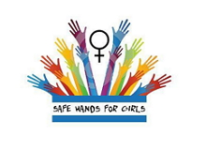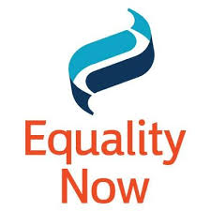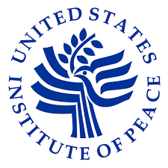

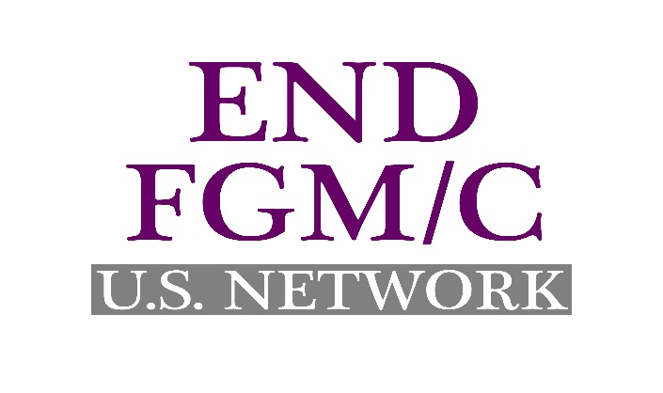
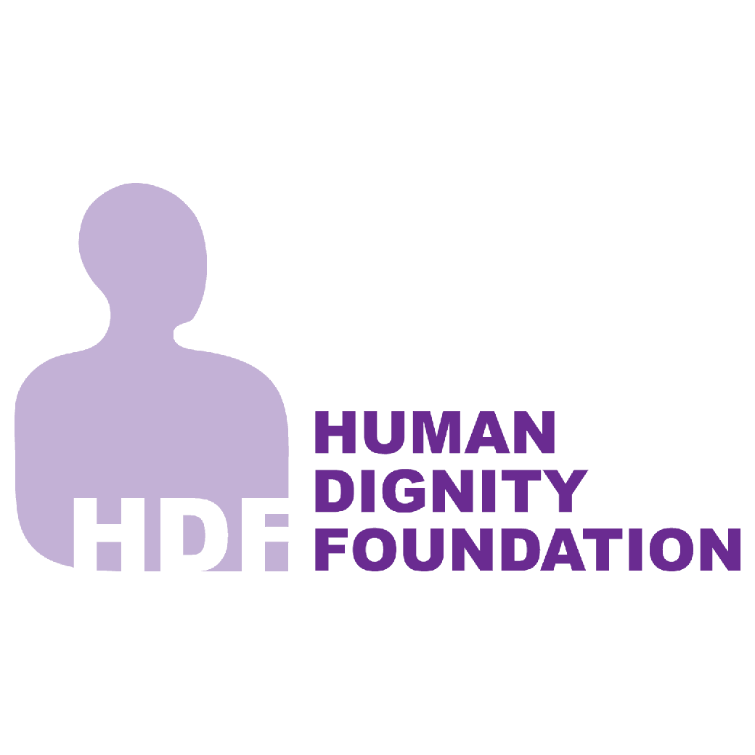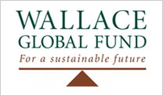

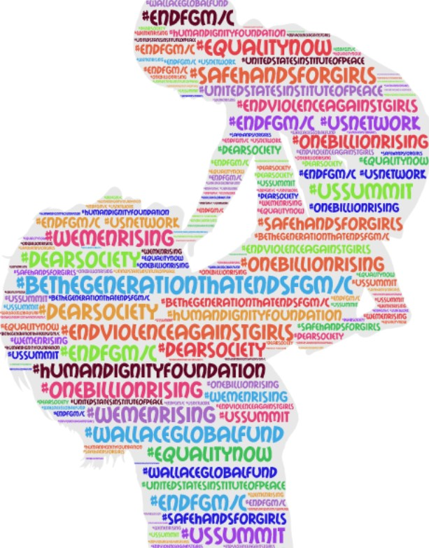

2nd December 2016
United States Institute of Peace, Washington DC.
By: Maria Saine
Prepared for: Safe Hands for Girls

TABLE OF CONTENT
ACKNOWLEDGEMENT………………………………………………….4
- ABOUT THE ORGANISERS……………………………….5-6
- ACTIVITY BACKGROUND AND CONTEXT……………………….7
  - Summit Overview
  - Goals and Objectives
- WELCOME AND KEYNOTE REMARKS…………….
  - Nancy Lindborg, President, U.S Institute of Peace………….8-9
  - Catherine Russell, U.S Ambassador-at-large for Global Women’s Issues………9-11
  - Shelby Quast, Director, Americas Office, Equality Now………….12
  - Jaha Dukureh, Founder & Executive Director, Safe Hands for Girls……………….13-14
  - Senator Harry Reid, U.S Senate (D-Nevada), Minority Leader…………….15-16
  - Lakshmi Puri, Deputy Executive Director, UN Women & Assistant Secretary-General of the United Nations…………….18
- PANEL ONE: Activist and Youth………………………………………………………….19-25
- PANEL TWO: Role of educators …………………………………………………………...26-30
- PANEL THREE: Medical and Service Providers Panel………………………………….31-36
- VIDEO TRAILER: Jaha’s Journey………………………………………………………………….37
- PANEL FOUR: Law Enforcement & Child Protection ………………………………………38-46
- PANEL FIVE: Religious and Community Leaders……………………………………………….49-50
- VIDEO: Address from The Right Honorable Priti………………………………………………50
- PANEL SIX: International and Sustainable Development Goals……………………………51-54
- STATEMENT: Congressman Joseph Crowley, U.S. House of Representatives (D-New York)….55-56
- PANEL SEVEN: Best Practices and Solutions……………………………………………………….57-60
- SUMMIT PICTURES…………………………….61-68

ACKNOWLEDGEMENT
Although the startup of any activity takes much effort, the U.S. End FGM Summit activity in Washington D.C was especially challenging. Many people put in hard work and contributed their energy in creating this activity and making it a success.
First, we would like to thank Human Dignity Foundation and Wallace Global Fund for financially contributed towards the implementation and success of the summit.
We would also like to thank Equality Now and the United States Institute of Peace for being incredible and supporting partners in the successful implementation of the activity.
From the outset, Senator Harry Reid provided continued and tireless support, as well as giving valued technical input in addressing the issue of FGM/C in the U.S and it is because of men like him that we are able to hold the first U.S End FGM/C summit.
At Safe Hands for Girls, we thank the event coordinator Haddy Mbowe and her team for putting up all the necessary logistics and implementing a successful summit. She and her team have helped guide the activity.

ABOUT THE ORGANISERS
- EQUALITY NOW
Founded in 1992, Equality Now is an international human rights organization dedicated to ensuring that women and girls around the world can live their lives free from violence and discrimination. Combining grassroots activism with international, regional and national legal advocacy, we envision a world in which women and men have equal rights under the law and full enjoyment of those rights. With partners and supporters in nearly every country in the world, Equality Now advocates to advance Legal Equality and to end FGM/ C, Sex Trafficking and Sexual Violence- all with a special focus on championing Justice for Girls.
www.equalitynow.com.org
- SAFE HANDS FOR GIRLS
Safe hand for girls is an Atlanta-based, survivor-led501(c)(3) organization focused on ending FGM/C and other forms of Gender Based Violence worldwide. Founded and led by survivor Jaha Dukureh, Safe Hands for Girls has succeeded in saving at least one hundred girls from FGM/C.
www.safehandsforgirls.org
- UNITED STATES INSTITUTE OF PEACE
The United States Institute of Peace works to prevent, mitigate, and resolve violent conflict around the world. USIP does this by engaging directly in conflict zones and by providing analysis, education, and resources to those working for peace. Created by congress in 1984 as an independent, nonpartisan, federally organization, USIP’s more than 300 staff work at the Institute’s D.C. headquarters, and on the ground in the world’s most dangerous regions.
- HUMAN DIGNITY FOUNDATION
Human Dignity Foundation (HDF) is a private. Swiss philanthropic foundation established in 2004 and governed by a Board of Directors. Guided by its vision of a world where all children and young people are living in dignity, HDF supports organizations to expand and improve their work in Africa and Asia in ensuring children grow up safe at home and in the community. HDF employs a holistic and engaged approach to grant-making, with a focus on harmful traditional practices such as FGM/C and Child Early and Forced Marriage ad Child Sexual Abuse and Exploitation. The foundation has a limited lifespan and will end its grant-making in 2021. Contributing to HDF’s strategic focus on support on supporting works towards ending FGM/C to date, HDF has provided approximately $8 million in grants to 12 organization in Kenya, the Gambia, Nigeria, Sierra Leone, United Kingdom, United States and the EU. The type of Programmes HDF supports to end FGM/C range from advocacy for policy reform, coalition building amongst activists, media campaigns, supports services for Diaspora survivors, and re-granting mechanisms to the grassroots and community based organizations.
Mary Healy is the Executive Director of Human Dignity Foundation. Prior to working with HDF, Mary worked with several international organization in Ethiopia, Cambodia and Somalia as well as short missions in over 15 countries. She is a nurse-midwife with a master in Community Health from Trinity College Dublin.
- WALLACE GLOBAL FUND
The Wallace Global Fund, a private foundation based in Washington D.C, is guided by the vision of the late Henry A. Wallace, former U.S. Secretary of Agriculture and 33rd vice president of the United States under Franklin D. Roosevelt. The Fund’s mission to promote an informed and engaged citizenry, to fight injustice, and to protect the diversity of nature and the natural systems upon which all life depends. The fund’s women’s right and empowerment program includes efforts to rid the world of FGH/C including mobilizing resources and policy support, catalyzing grassroots action, backing advocates and survivors, and mobilizing resources in supports of community-led processes of social change. FGM/C has been a pillar of the fund’s women’s and rights grant-making since its inception, beginning with Dr. Gordie Wallace’s pioneering FGM/C advocacy in the 1970s -1990s.
Susan Gibbs is a philanthropic advisor to the Wallace Global Fund, where she manages the fund’s grants portfolio on women’s right and empowerment, with a current focus on FGM/C and women’s economic participation. Prior to lunching her philanthropic consulting practice, she held program positions at The Summit Charitable Foundation, the Pew Global Stewardship initiative, and the Pew Charitable Trusts. She has also consulted for the David and Lucille Packard Foundation, the John D. and Catherine T. MacArthur Foundation, and the Garfield Foundation. She has held previous positions in international education, development and humanitarian relief in Switzerland, Pakistan, India and Egypt. She also serves as the executive director of the SS United States Conservancy, a maritime preservation organization dedicated to saving “American’s Flagship,” the SS United States. She holds a Master’s degree in International Affairs from Colombia University’s School of International and Public Affairs and a Bachelor’s degree magna cum laude from Brown University.

ACTIVITY BACKGROUND AND CONTEXT

- SUMMIT OVERVIEW

Safe Hands for Girls, Safe Hands for Girls, the U.S Institute of Peace, the U.S Network to End FGM/C, with support from Wallace Global Fund and Human Dignity Foundation have organized the first End Violence Against Girls; Summit to End FGM/C in the U.S. This creative, positive and engaging event brings together domestic and international thought leaders-survivors, civil society, front line professionals, and government to discuss how we can together end FGM/C by 2030.

The Summit will facilitate a cross-sectoral approach, in the U.S. and internationally, to ending FGM/C. Subject matter experts will share top-line recommendations across sectors, including; survivors/activists, child protection, education, health care, community and faith-based groups, law enforcement and government to respond to and end FGM/C.

- SUMMIT GOALS

- Share best practices in ending FGM/C and supporting FGM/C survivors.
- Advance a comprehensive multi-sectoral approach to ending FGM/C and providing services to those affected, including healthcare, child protection, education and law enforcement.
- Foster increased coordination and collaboration among government, front line professionals, religious and community leaders, and activists focused on protecting girls from violence and eradicating FGM/C by 2030.
- Launch inclusive and vibrant U.S. End FGM/C Network.
- Strengthen international movement to End FGM/C.

WELCOME AND KEYNOTE REMARKS

- NANCY LINDBORG

Nancy Lindborg, President of the United States Institute of Peace(USIP) began by expressing how exciting it is for her to welcome everyone to the first ever U.S End FGM/C Summit. She went further to express how honored she and her institution are to have Senator Harry Reid not only in the summit but also very pleased to welcome him back to the United States Institute of Peace because he has been a long time friendly supporter of the institute. She commented that Senator Harry Reid has been an extra-ordinary champion of women and girls’ rights since 1996. In her words, she stated that “Senator Reid has sponsored legislations on these issues and has been a passionate advocate throughout his career”. She continued to reiterate on how Senator Reid inspires all of them.

Going further, Nancy Lindborg mentioned that it was congress that founded the United States Institute of Peace thirty-two years ago it dedicated to the preposition that peace is possible, practical, absolutely essential for our global and National Security and USIP pursues a mission of a world without violence conflict by working with partners, individuals, organizations, and governments in areas that are affected with conflict to give them tools, information, and training that helps them to avoid conflict so that it doesn’t result to violence.

In addition, she mentioned that everyone was gathered at the summit to discuss and address FGM/C which is a particular form of violence and with shared commitment of ending violence against girls and looking at strategies that might end FGM/C. She made it clear that the goal to end FGM/C was enshrined in the new Sustainable Development Goals (SDGs) in a very specific indicator under goal five for Gender Equality. Thus, she said that it has already been agreed upon by Nations around the world that we will eliminate FGM/C by 2030. She however emphasized that there is still a lot of work to be done because more than two-hundred million women and girls across thirty different countries are still living with complications from FGM/C despite all the progress made in the legal, health and education arenas.

In rounding-up, Nancy Lindborg was pleased to welcome Catherine Russell back at the USIP as the U.S Ambassador-at-large at U.N Women’s Issues. She described her as the “perfect person” to get the summit started. Nancy went further to give a brief biography of Catherine Russell. She mentioned that Catherine is the leader of the State Departments effort to advance gender equality and the empowerment of women and girls worldwide. Nancy has focused on addressing Gender-Based violence issues and promoting women’s full participation in society and investing in adolescent girls and making sure that women’s issues are part of our foreign policy. Prior to this position, Nancy stated that Catherine Russell was deputy assistant to the President to Dr. Joe Biden and throughout her time at the White House, she coordinated the administration strategy to prevent and respond to gender based violence globally. She concluded by asking the audience to join her in inviting Ambassador Catherine to the stage.

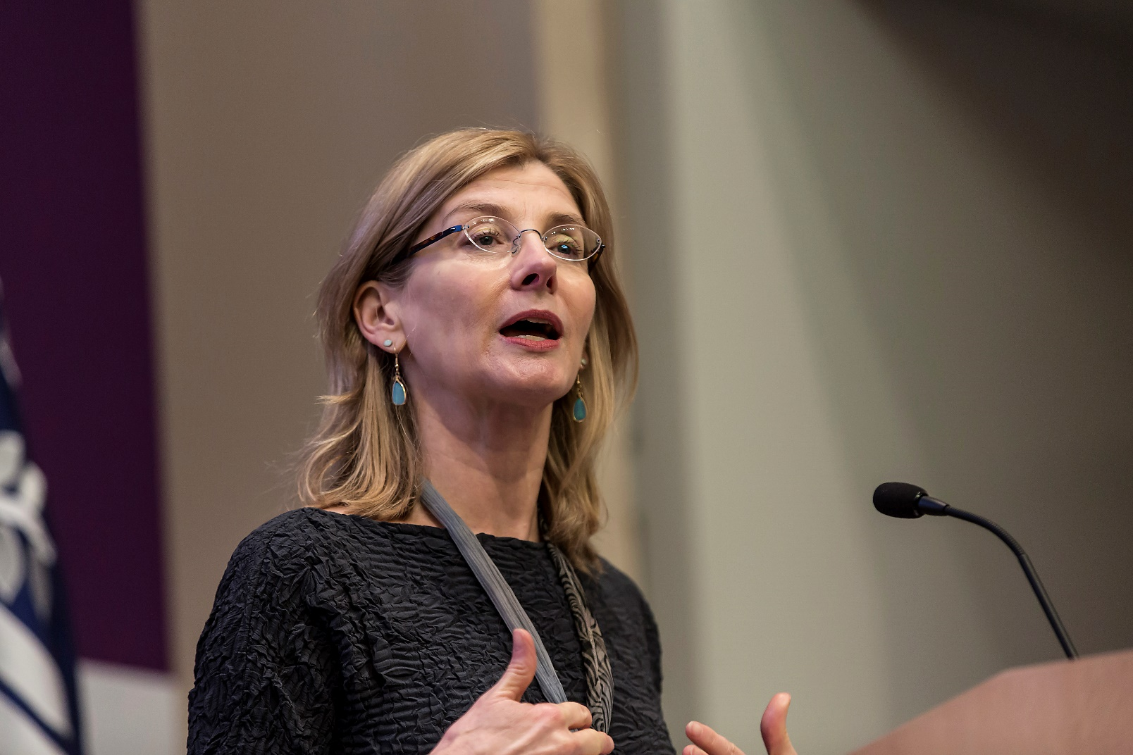
Nancy Lindborg, President, U.S Institute of Peace(USIP)

- CATHERINE RUSSELL
Catherine thanked Nancy for her kind words and said that it is always good to come to the USIP. She also sent a message of appreciation to Senator Harry Reid who she said has been an incredible advocate in the issue of women and girls. She expressed how incredible Senator Reid has been in focusing on the issue of FGM/C in the U.S. She then thanked him for the leadership and support.She then thanked the organizers, Shelby Quast of Equality Now and Jaha Dukureh of Safe Hands for Girls both of whom she said she has worked with before.
Catherine expressed how hard it is to believe that this is the first ever U.S End FGM/C summit and that it has taken them so long to get it done. She urged everyone in the hall to get on top of things. She then said the fact that this summit is the first of its kind in the U.S speaks of the challenges we’ve been facing in tackling the issue of FGM/C.
Notwithstanding, she commended some of the progress that has been registered and that is thanks to people like Jaha Dukureh who is the Founder and Executive Director of Safe Hands for Girls , Shelby Quast of Equality Now and the rest of the people in the Hall who have taken interest. On behalf of the United States of America, she thanked many groups, particularly the survivors who work tirelessly to end the practice both in the U.S and the world at large. She said she attended the summit to say a big thank you to everyone.
She assured that policymakers in the U.S are paying attention and other survivors are finding the support and community that they need to have the courage to come out and talk about these issues. She said the silence is slowly receding in Egypt and with local theatre performances using humor to spark conversations in families and communities. She also stated that the silence is receding in Universities where research is being conducted for the purpose of recommendations. Also, in the U.S thanks to people like Senator Reid. She however made it clear that whilst the silence is receding, the practice itself is not. In the past years, she said, UNICEF’s estimate of how many women and girls have undergone the practice of FGM/C has jumped from seventy million to two-hundred million. This she said is very shocking and that now more than ever, this is an issue that needs our attention that is why the United States is part of the global movement to prevent FGM/C.
She referred to the Policy strategy signed in 2012 by president Obama which recognizes FGM/c as a form of violence against girls that requires a multi-sectoral response and it includes community led responses, a change in social norms and importantly, political commitment and leadership. In addition to the policy strategy signed in 2012, she mentioned that FGM/C is also addressed in the first U.S strategy on adolescent girls which they issued last year. She stated that it is a very strong document. She encouraged everyone to look at it on the State Department website. On her side, she commended the State Department for making FGM/C one of their key strategies in ending violence against girls. She realized that strategies may not sound very exciting but at the same time she wants to underscore that the foundation for the work to end FGM/C going forward is very strong and strategies are a critical part of that effort.
Despite her time as the Ambassador-at-large in UN Women’s Issues, she assured the audience that the work will continue and because it is in place, policies are made from the foundation of incredible commitment on the part of the United States and around the world. She said the foundation was built on diplomacy, through programming and through partnerships.
In her conclusion, Catherine highlighted some of the work they have done that has proven to be successful. She stated that they have engaged religious leaders which are absolutely critical. Two years ago, her office launched an online campaign on the International Zero Tolerance Day celebration and that was the first campaign of any sort. Since then, she added that they have launched other FGM/C campaigns using fathers to help advance gender equality in their personal lives. She also mentioned how the UN diplomats held a National campaign to end the practice in Guinea and two-hundred villages which ended up abandoning FGM/C thanks to the campaign.
She comments that whilst the UN can take credit for the success in Guinea, they certainly did not do it alone. She said it was successfully because they had a tremendous group of partners from the government of Guinea to local and international groups, to young women and community leaders. She reiterated on how partnership is key and that on one organization can do it alone. In her words, she said “We need to work together to be able to do it so that the work will continue, our commitment will continue but whilst we also continue, there is a critical need for survivors and organizations to push for progress and to speak out.”
In her conclusion, she urged everyone involved to keep pushing, keep the government accountable and keep standing up for girls and survivors. That way, she said change becomes a reality and FGM/C will be history.
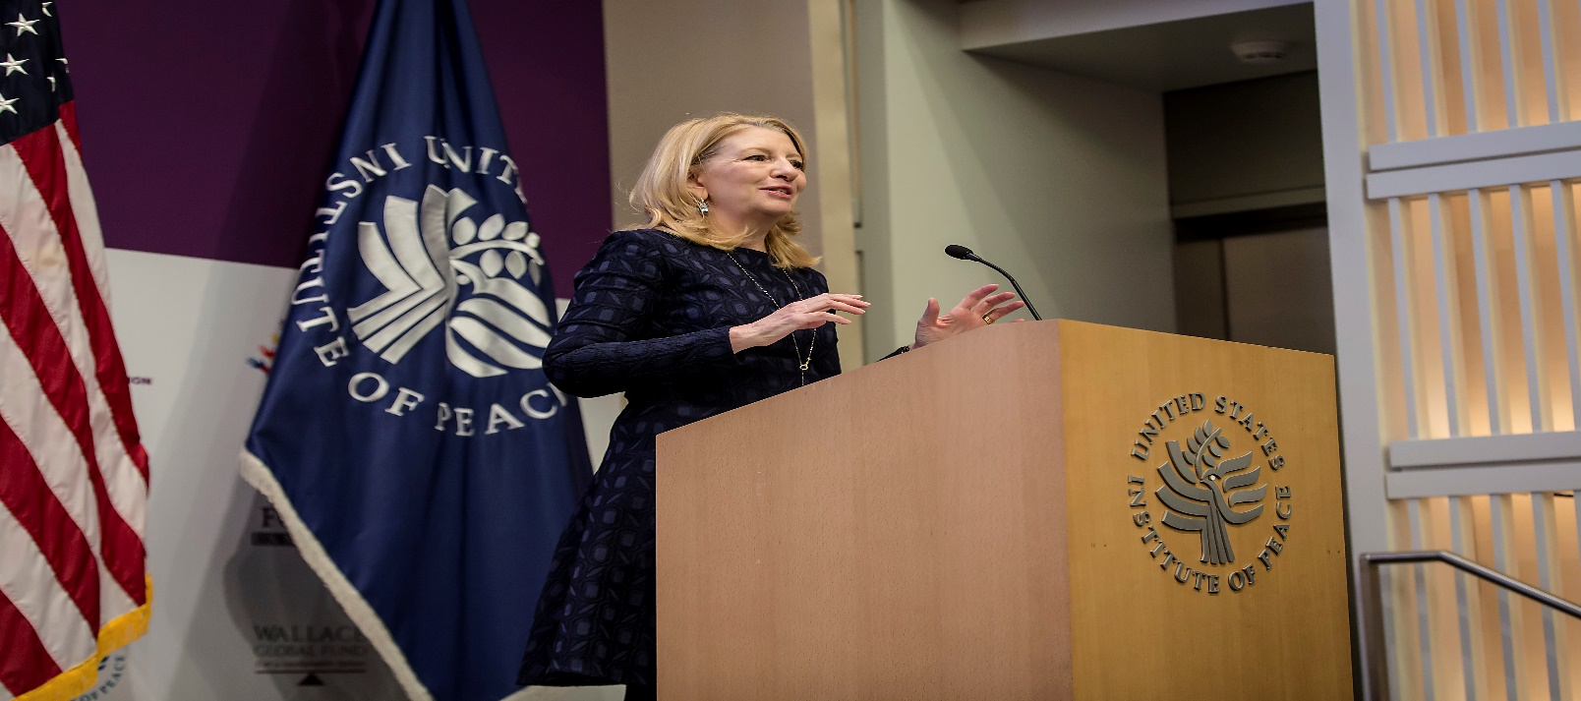
Ambassador Cathy Russell delivering her statement

- SHELBY QUAST
Shelby Quast commenced her statement by first stating that FGM/C is an extreme form of violence that sits squarely in the human rights, security and development agendas. According to her, this is why partnership in ending FGM/C is really important.
Shelby went further by giving a brief synopsis of what Equality Now is. She stated that Equality Now is an International Human Rights organization dedicated towards ensuring that all women and girls around the world can be free from all forms of violence with partners nearly in every part of the world.
She said that the summit brings together about two hundred thought leaders from over twenty countries and many more are joining us via live stream to discuss how we can come together and end FGM/C by 2030.
Shelby stated that she is humbled and inspired to be surrounded by such passion and commitment and extended a huge thank you to Wallace Global Fund, and Human Dignity Foundation who made all of this possible. She further mentioned that coming together is the beginning, keeping together is progress, but working together is progress and that we have a lot of work to do together.
In her conclusion, she welcomed on stage an important advocate, change maker, super mum, Time most influential woman and her co-organizer in the summit, Jaha Dukureh, the founder and Executive Director of Safe Hands for Girls.
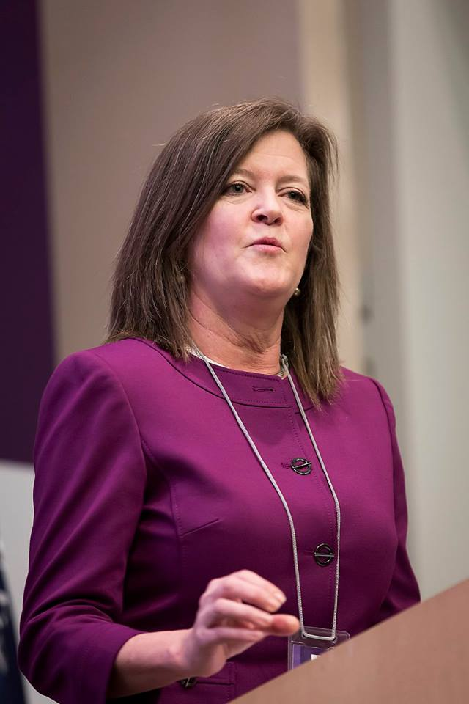
Shelby Quast, Director, Equality Now delivering her statement
- JAHA DUKUREH- FOUNDER & EXECUTIVE DIRECTOR, SAFE HANDS FOR GIRLS.
Jaha began by sincerely thanking all the participants and dignitaries for making time out of their busy schedule to be present and contribute to the success of the summit.
Jaha described what Safe Hands for Girls is stating that it is a Survivor led Non-Profit organization that started in her living room. She said the organization started because she saw that in Atlanta, there were a lot of girls in her community who have experienced FGM/C like she did and no one was speaking for them and because of that she felt the need to do something. Over the years, the organization has transformed not only to do amazing work in The Gambia but now they are working with their sisters across Africa to make change. She made it clear that today is not so much about her and her work but it is about everyone involved in the campaign to end FGM/C to make change.
Jaha highlighted that the summit and everything that has been happening for the past few days before the summit wouldn’t have been possible without the support of Human Dignity Foundation and Wallace Global Fund who not only have supported the summit but have been amazing partners working with Safe Hands for Girls and providing them with all the support needed.
Jaha also mentioned that the summit is extra-special for her because one person who has been with her and her organization from the beginning of the campaign was present. She stated that the person is the most powerful man in the U.S senate and this is an issue he says as a white man, it was weird for him to talk about it and yet he still talked about it. Every time she said she needed him, Senator Reid will bring her in and bring his colleagues in to listen to her and he has been doing that since 1996 for his entire career and for her, it is a bit emotional that Senator Reid is retiring from the congress. Without him, Jaha said a lot of the things they have accomplished in the U.S wouldn’t have been possible.
Jaha, just like previous speakers, thanked Senator Harry Reid and assured him that they know everything he has done for them and they don’t want him to leave without showing him just how much they appreciate him.
Thus, Jaha took the opportunity to award Senator Harry Reid with the first Global Advocates Award for Girls Award and thanked him for his services to the people.

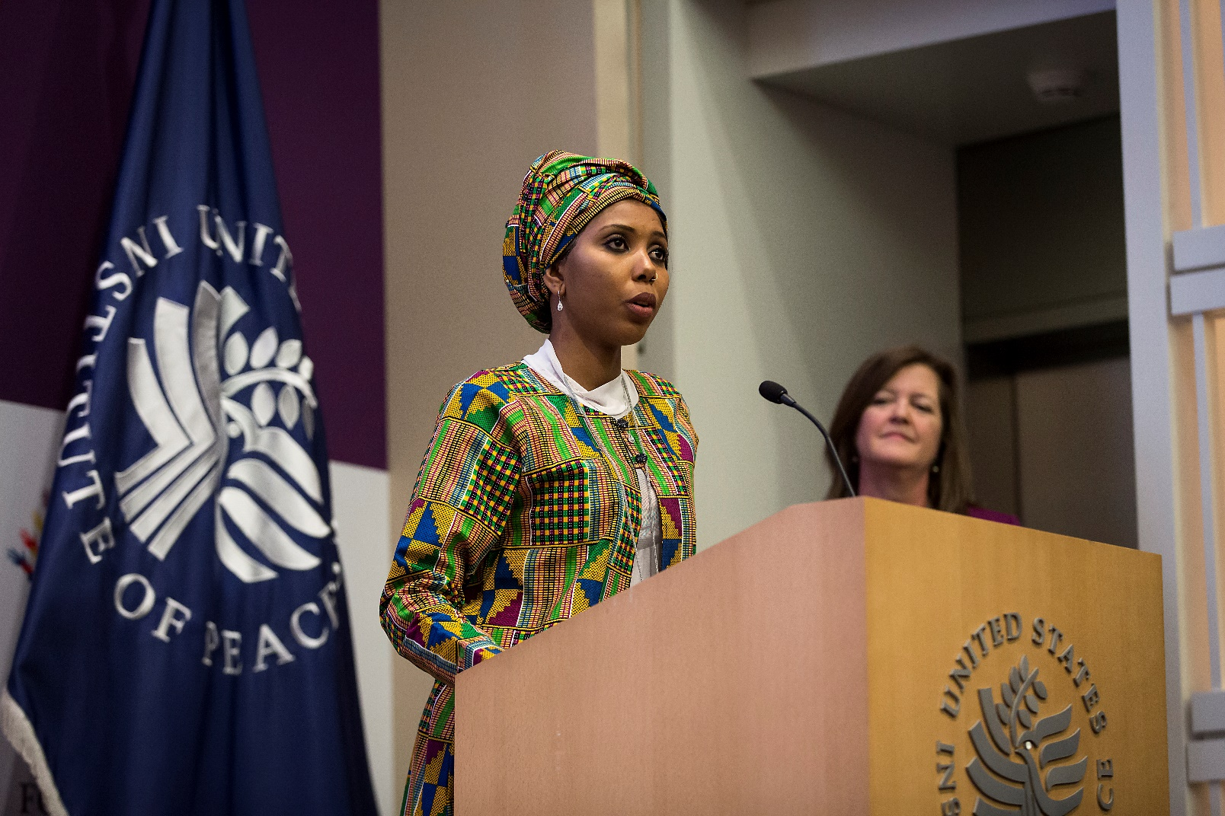
Jaha Dukureh, Founder & Executive Director of Safe Hands for Girls

- SENATOR HARRY REID
Senator Reid accepted the award in a humble fashion and thanked Jaha for her kind words and Shelby for everything she has done.
Senator then reflected on how a young girl was mutilated twenty-two years ago, today twenty-two years later, he said millions of women like Jaha Dukureh are still being mutilated. He said he is leaving congress after thirty-four years feeling pretty good with what he has been able to accomplish but he still feels like a total failure when it comes to the issue of FGM/C in the U.S. Senator said that he is happy that people now freely talk about it in the U.S but nothing has been done and no help has come from the congress. They have passed a few bills which is better than nothing but he still feels like they could have done more after twenty-two years. Senator Reid was happy that everyone was at the summit inter-alia to meet others for change. He reckons that the U.S government has been a total failure because the U.S is a big and powerful nation. He went further to refresh about the concerns for Human Rights but pointed out whether the audience are concerned about the rights of the million girls being mutilated around the world.
Senator then explained to the gathering how difficult it was for him to do something. From bringing together his staff and fellow senators to trying to involve the public. But with these strategies he still couldn’t gather much attention around the subject matter. We need more than “talk” he said. “We have agendas that have addressed this on an ad-hoc basis but nothing permanent, no plan. If FGM/C is not an issue of Human Rights, then nothing in the world does” said Senator Reid.
Senator Reid then expressed his disappointment in religious leaders around the world and how the world has been silent about it. He however remains hopeful that the churches would start making sermons about this publicly. He urged everyone to talk about it ranging from local government, state government and federal government and for them to do whatever they can to push the UN to focus attention on this. He hopes that the summit will cause people to engage and not feel embarrassed and to charge forward and not only work with congress but with state legislation, and local government.
In his conclusion, he expressed that he does not feel good with what has been accomplished with the mutilation of girls and urged the participants to push harder.
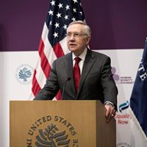
Senator Harry Reid

- BAN KI-MOON- SECRETARY GENERAL OF THE UNITED NATIONS
Jaha Dukureh apologized on behalf Ban Ki-Moon for not being able to make it to the summit and awarded him with the first Global Advocates Award. Notwithstanding, the Secretary General recorded a video of him making a statement which was played.
In his statement, the Secretary General said he was honored to receive the Global Advocates Award on behalf of his dedicated UN colleagues and apologized for not being able to make it. He commended Equality Now and Safe Hands for Girls for organizing the U.S End FGM/C summit and he also applauded the Big Sister movement. According to the Secretary General, millions of girls worldwide are born perfect but at least two-hundred million have endured the practice of FGM/C. In the U.S, he said, more than half a million are at risk of being mutilated or have already undergone the practice. This according to the Secretary General is shocking and it must be stopped. He said the UN is making a difference but we cannot stop until every girl is safe.
He continued his statement by saying that he is inspired by young women like Jaha Dukureh. He said when he first met Jaha last year; Jaha told him “women who know the pain are standing up to say we do not want this”. He then called on all people especially men and boys to support their plea. He thanked the health workers, politicians, religious leaders, activists, policymakers, media outlets and young people who are speaking out.
He concluded stating that for the common future, we should secure the health, life and dignity of girls everywhere.
At the end of his video, Jaha presented the award to the Deputy Executive Director, UN Women & Assistant Secretary General of the UN who received the award on behalf of the Secretary General.
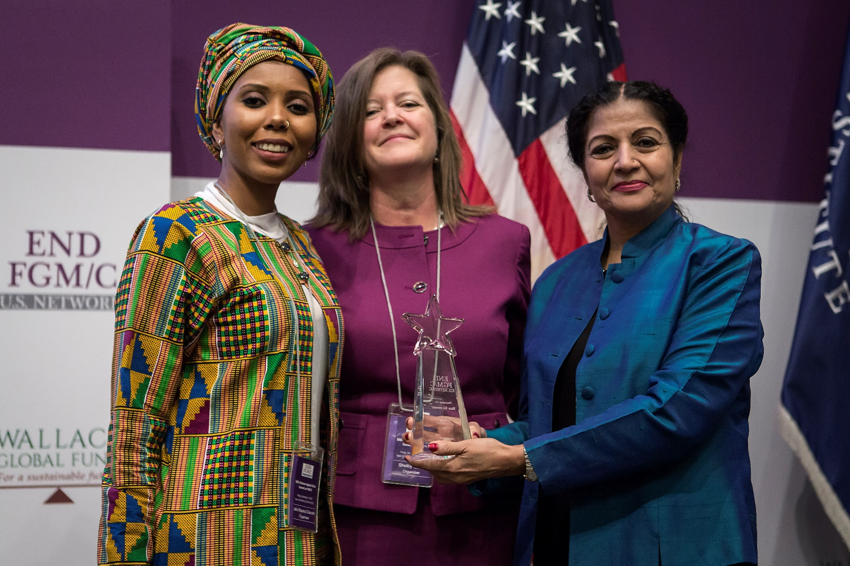
Lakshimi Puri, Assistant Secretary-General of the UN receiving the award from Jaha and Selby on behalf of Ban-Ki Moon.

- Lakshmi Puri- Deputy Executive Director, UN Women & Assistant Secretary-General of the United Nations
The last statement of the day was delivered by Lakshmi Puri who began by teaming with Senator Reid that if FGM/C is not a violation of human rights, what is? She again teamed with Senator Reid that there isn’t enough progress but also buttresses that the UN has moved globally and last year 193 countries met at the Sustainable Development Goals summit and declared FGM/C as eliminating and declared the determination to be a sustainable development goal/target. That she said is progress and they have moved. She then acknowledged the role of the U. S government, the civil society, congress and political leaders. She then told the audience that harmful traditional practices, such as FGM/C, cannot be treated in isolation but holistically with a focus on prevention.
Lakshmi expressed how happy she is that the summit is holding and hopes that we reinforce the methods to end FGM/C. She said interventions must add social norms that entail control by men and that push women to cut out their children from generation to generation because they think it will protect them. She urged everyone in the hall to end FGM/C within a generation. Ending FGM/C she said is an essential part of realizing the sustainable development goals including the targets on health and well-being, quality education, safe motherhood, and economic growth. All of which she said underpinned by work that empowers women and girls and achieve gender equality.
She also reinforced that while we have legislations at the global level, it is not enough. We need to put the commitments into actions and take responsibility as a global community. She then pointed out that the global community of the U.S is critical in this. At U.N Women, she said they are happy to be collaborating with the UNFPA-UNICEF joint programme in ending FGM/C to support countries to address the demands side of it as much as dealing with those that are perpetrating and cutting off and finding other alternatives that we address.
In her conclusion, he said that the award to the Secretary General highlights once again that the United Nations and its persistent commitment to a future where every woman and every girl can have inherent dignity and human rights latest by 2030.

PANEL ONE: ACTIVISTS AND YOUTH
This panel discussion brought together well-grounded activists who are well experienced in activism and are equipped with the ability to dilate on topics especially related to youth work in the campaign life and well-being of women and FGM. This panel was moderated by Maryum Saifee from the U.S State Department Office of Global Women’s Issues. The panelists are as follows:
- Aissata Camara, strategic relationships manager and program director for NYC junior Ambassador Program. She’s also the co-founder of There is No Limit Foundation an international non-profit organization empowering women, children and communities through entrepreneurship education.
- Leyla Hussein, psychotherapist and founder of the Dahlia Project. Leyla is also the Global Ambassador for The Girl Generation
- Domtila Cheseng, regional coordinator in Kenya for The Guardian Global Media Campaign to End FGM.
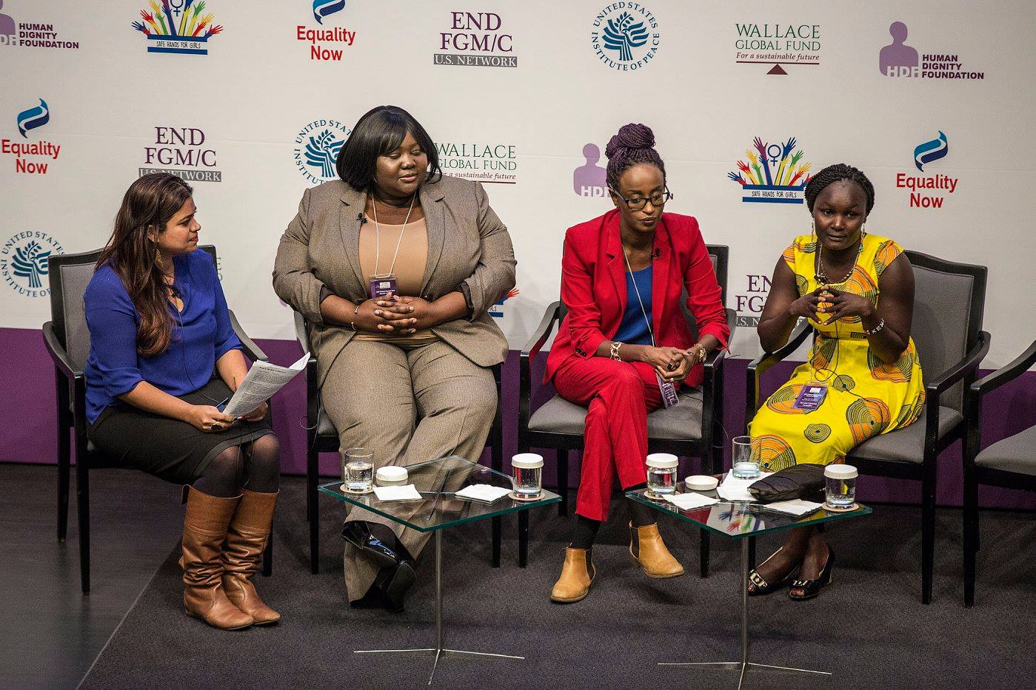
The panel on Youth and Activism
Maryum began by expressing how honored she is to be part of the U.S End FGM/C summit. She introduced herself briefly as a survivor of FGM and also an activist. She then introduced the panelist and went straight ahead to the questions.
Question
As survivors and activists, what are the greatest challenges that you’ve faced and why is a survivor voice so important in the campaign to End FGM/C?
Responds
- Aissata Camara
First of all, I just want to say that I work in the mayor’s office in New York City. I’m really here because I am the Co-founder of There is No Limit Foundation and I am also a survivor of Female Genital Cutting. It took many years for me to finally sit in a room and to even say that I was a survivor. I think one of the greatest challenges we face as survivors is being able to move beyond our stories. When I became an activist, it was really hard. It more of the fact that you are a survivor and there is no care about the fact that I am working in the government or that Leyla is working as an amazing therapist or that Maryum is working for the state department. That’s the first challenge.
The second challenge is creating platforms that also empower survivors to tell their stories. I think these are the kind of movements we are looking for. Having people in a room and really being able to tell their stories in meaningful and respectful manner.
- Leyla Hussein
For me one of the key challenges as a campaigner, as a survivor and as a therapist who has to create spaces for women is bringing all the key people together in one table. Sometimes one can get lost in this idea that only survivors can deal with it but no. We can’t. We need a team behind us. I need to work with policymakers, I need to work with lawmakers, I need to work with the health and education sectors. The key challenge is always bringing these people together to the table and make sure that you get the right people. Personally, what was really challenging in the UK was that there was a lack of understanding on what FGM is. From many years, we treat it as it was an exotic disease or something. As a campaigner and activist, the key challenge is changing the language. Some time back I walked into an Arena where it was called a cultural religion. Clearly for me this was one of the worst forms of child abuse but this happens. I also want to clearly stress everyone in this room. We keep saying this happens to women but it also happens to children who then become a woman. So, we are talking about a four-year-old who did not have a say or consent to this. So as a campaigner, I am constantly changing that narrative. This is about controlling the sexuality of women and this is also a global issue. FGM is not different from any form of oppression in women and girls. When we treat it as that, we will end it because ending oppression to women will end any form of violence against women. So FGM is just part of the menu. That’s the constant challenge and we need to keep bringing that back. We cannot keep treating it like its different. For me if anybody commits any crime against a child, we have a child abuse Act in the U.K so we use that.
- Domtila Cheseng
One of my greatest challenges as an activist is getting appreciated for the work that I am doing in my community. I have many times said that the grassroots activists are the real deal. We have the answers but for me the passion to be able to accelerate that movement that I’ve started and to maintain the momentum, I need support. But how do I convince the donors? I cannot move from one village to another village with my two legs. I can do that but I can only reach few villages. We need the support, we need the people to rally behind us, we need the people to trust us but the challenge has been that its taking people too much time to believe that these young African girls can actually manage some amount of money. We are sitting in a room today talking about FGM. We’ve done it many times. Talking about strategies, talking about how do we get this funding out there, talking about who do we work with, talking about what is the solution, what is the right channel, and what are the approaches. We are the approaches. We are the answers.
- Leyla Hussein
Just to add to what Domtila has just said, accountability from our politicians is absolutely vital in this because as a British citizen, I am not going to beg my government to protect my child. It is their job and we pay taxes. We put them in that position to protect our rights. I don’t think we should put ourselves in a position where we have to ask for favors. The fact that we have is absolutely criminal as far as I am concerned and you know when we say every child matters and for a fortune, this is globally. We have picked and chosen those that matter. If two hundred million men had their penis removed there would be war and millions will be funded into it but with two hundred million girls, it’s a totally different story. We need to be honest. I think if we really want to deal with this issue, we need to be blunt and open to discussion around race, gender and sexuality because this is what activism is about. We cannot shy away from that conversation. We’ve been ignored because majority of us are dark-skinned.
- Aissata Camara
To add to that, I think that you are saying Leyla is too critical in terms of the survivors and actually all of us owning this campaign and owning this movement. For many years, we used to sit in rooms where we have people throw numbers without realizing that they are actual people behind those numbers and I think that it is so powerful to be in this room to have Leyla and to have all of us talk about Female Genital Cutting not as if it is some fiction or storytelling but the fact that it is real, it is happening and if we do not stop it, it will continue. I have a niece and she’s 15 years old. She’s uncut and I told her that she should be proud of that because when I was growing up, being uncut meant that you are not part of society and we going to shift this, we are going to change this but it really must be owned by the survivors and owned by the communities.
Question
I want each of you to talk about the connections you have with these movements; the big sister movement, The Girl Generation and others and how you are building these trans-national sort of movements as survivors in your organizations?
Responds
- Domtila
I want to talk about the Big Sister Movement because that’s where I feel like I belong. I have been a Big Sister since I was 11. I have three sisters in my family. My younger sister was cut when I was in school but I ran away from home to escape Female Genital Mutilation. I had to come back afterwards to safe my other two sisters because I could not afford to lose the rest. So I have acted the role of a Big Sister and it started with my family and it translated into my village and now I have moved further to the communities and at this point I am supporting other Big Sisters and Big Brothers from other communities.
The Big sister is standing out to be a model that is solving the equation of how to end FGM. I was sitting down somewhere today and I was thinking there are so many dots to be connected in ending FGM. But how do we reach out and connect all these dots. We have the funding, we have the implementation bit, we have the action, we have the problem and we will end up sitting in one room again if we do not connect all these dots. So, we sat down with a group of other Big Sisters from different countries. We met in Glencree and we figured a way of how to simplify the equation. There is a way and the only way is to identify the Big sisters who are already doing the job and empowering these Big Sisters. The Big Sister is going to connect all these dots. For instance, most people will call it a girls’ issue, but I will call it a responsibility. I am that responsibility. I am the person implementing that action and I am the solution. That is the Big Sister Movement. The Big Sister is going to take up the responsibility. We are not going to request for anybody to pay us salaries. We only want to be facilitated. We are only begging that you believe in us. You have spent so much time to bring us here today and there has been so much work done to make sure that at least one flower has emerged from a village and I am that flower. So, you have to believe in me, you have to believe in the Big Sister. We can handle this.
There is a turnaround in the campaign to End FGM. It is no longer about sending Mr. X to go to Kenya to do a research on FGM. No, you don’t. There is no point.

- Leyla Hussein
I believe that working together is quite key and to ensure that I am involved in whatever Domtila and Aissata are doing. This morning I walked up to the Director of The Girl Generation and said to her that we are going to meet with the girls in Sahiyo and the girls from India, Russia, Colombia, Malaysia and the Indonesian girls. I told her that we need to bring these sisters on the table. In Indonesia for example, we are talking about 18 million. We need to ensure that these women that we do not see on the frontline are also part of the table. How do we make this possible? For me as a therapist and I always say this, my aim is to create safe space where the women can come and have a dialogue. So now that all of us are here, the Big Sister, Aissata or Sahiyo, we now start creating those spaces to bring in our Malaysian sisters, our Russian sisters, Indonesians and Columbians. We’ve done it. We just need to move to the next step.
- Aissata Camara
Definitely. I think that Leyla is echoing my thoughts exactly. What my sister and I have started is the There Is No Limit Foundation. We started it with 18 dollars and when we started it we made sure that at the core of our work is dignity and security. When we started looking what dignity and security means, we found out that the first thing was security to our own body. You needed to feel safe in your own body and FGM/C really changes our relationship to our body and really changes the way we think of ourselves and the way we think of others. Our movement is about the fact that it is not just an African issue. This is an issue that is affecting many more people and If I just may, with There Is No Limit Foundation, with just Guinea being the second country with the highest rate of FGM/C and the fact that it cuts across, it doesn’t matter if you are poor, or if your father is a politician. My father is yet I was still cut. FGM/C was outlawed in my country and I was still cut. What we find that is going to be successful is empowering youth and just giving people the platform. People just need to start talking about Female Genital Cutting because it is the biggest secret that everyone knows about., everyone is ignoring and we no longer ignore it and I refuse to ignore it, my sisters will not allow anyone to ignore Female Genital Cutting anymore.
- Leyla Hussein
A little hypocrisy we do in this conversation sometimes because in U.K for example, the second most popular cosmetic surgery is “Designer Vagina”. My white friends can do anything they want with their vaginas but as a black woman, I am not allowed to. That’s a double standard in my eyes. We need to go back to the policies put in place. For me this has a lot to do with body image. If you speak to a lot of white women, they will say to you “I did it because my husband has an affair and she has a tight vagina”. If you watch a video clip of Osmond’s wife, they took a video to one of the TV shows and she said she had her vagina tightened and people were laughing about the way she talked about it and they said to her “how was it during sex?’ and her response was, “it was painful but my husband enjoyed it”. This is exactly why we are mutilated. So, we can’t say that one is barbaric and the other is okay, it’s a choice. This is about what is it a society that we are doing and feeding our girls at a very young age that there is something wrong with their bodies from day one. Why can’t we accept our bodies for the way it is?
Question
Give me an example of something is has worked well for you and has the potential to scale?
Responds
- Domtila Cheseng
For me the Big Sister which has already started because we are now developing the structures. So I can say that it’s a Big Sister because I Know it is going to work. But at this point, I want to say that one thing that has definitely worked for me and even helped me to achieve the little I have achieved and the confidence I have today is the media campaign. I got involved in a media campaign. I was telling my friends yesterday that If I post something on Facebook and Leyla likes it I get confident. It hasn’t just worked for me but for so many other girls and boys in the campaign in Kenya. Last year, I brought together thirty-five young grassroots activists who were not attached to any organization but they were desperate to bring change in their villages. They were brought together in a campaign academy in Nairobi. Now their young people have gone back to their villages and have set up their own organizations. They are using the community radio stations to pass out their messages because today If I go in a market place and shout about ending FGM I can only talk to a few number of people but if I go the local radios stations, because I know the means that will work, I know what to need to talk about, I respect my culture and I am only against the harmful traditional practices, I know the message. I know if I bring a doctor and a lawyer from the community and if we take our message to the community radio stations, they know the message that they will pass out and that message will not only reach his or her family but it will reach the entire community. That is the way we are using to accelerate the change we want. The media campaign is really working for us just like I did with the poster competition.
- Leyla Hussein
For me it is changing the language and the narrative. FGM is one of the worst forms of child and sexual abuse because touching children’s genitals is sexual abuse because if I touch a child’s genitals, I will be on the sex offenders’ list.
- Aissata Camara
I think the youth are going to be the spark that’s going to light this movement and so what we’re doing at There No Limit Foundation is to really work with young people and so it’s about the sisterhood. It is also about just all of us coming together as a community. So, let’s keep working.
Question
Yes or No. Are we going to end FGM/C by 2030?
Responds
- Domtila Cheseng
Yes
- Aissata Camara
Hell Yes

- Leyla Hussein
Yes, we are going to end all forms of violence against women.
Maryum rounded up and thanked the panelists for their contributions. This was followed by a story titled Her Story; Uncut and a Networking Break.

PANEL TWO: ROLE OF EDUCATORS
This panel was moderated by Angela Peabody; Executive Director/Founder, Global Women Peace Foundation. With her, she had a group of people with expertise on exploring the role of educators in Ending FGM/C. The panelist were as follows;
- Kakenya Ntaiya, founder and President of Kakenya’sCenttre for Excellence.
- Djessou Kouyate-Conteh, Senior Project Officer, Inter-African Committee, U.S.
- Alison Milofsky, Director of curriculum and Training Design, U.S Institute of Peace
- Sami Ullah, Events and Development Coordinator, Integrate Bristol U.K.

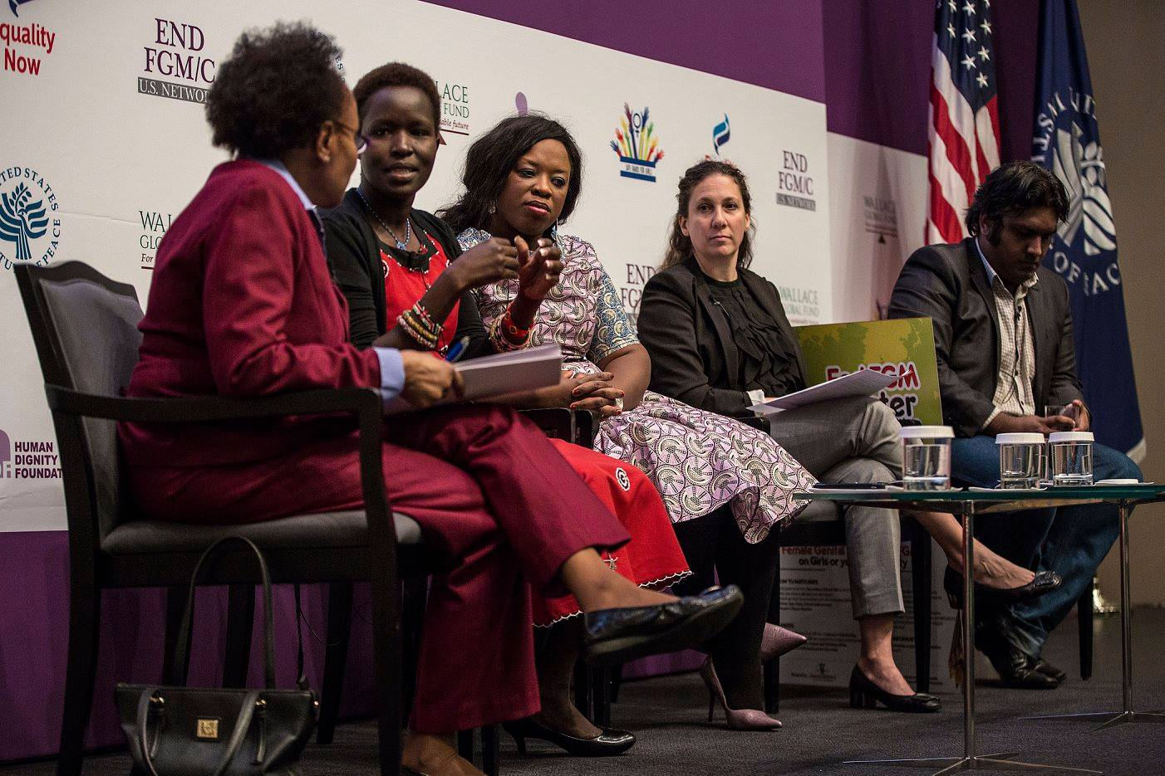
The panel on the Role of Educators in ending FGM/C

Angela expressed her pleasure in being part of the summit and introduced the panel. She then went straight to asking questions to the panelists. Her first question was directed to Kakenya Ntaiya.
Question
How has educating girls through the school system worked?
Responds
- Kakenya Ntaiya
I think school is one of the quietest place where you have everybody in one place. In schools, you have the parents, teachers, government, the girls, and literally the whole community there. I started a school because I knew that education has made a difference in my life and at some point, I learnt about Female Genital Cutting when I was in college. I was very shocked that I should have learnt it earlier and that is why I say we should go back to the schools because a school is where we can start enhancing what is there and in most schools, we have the sexual reproductive and sex education. From there is where we need to look at the holistic approach and where FGM/C is not just one part of something but we have to look at it as a comprehensive thing. We have to look at it as a link to early marriages, a link to teenage pregnancy, a link to girls dropping out of school, and so if we can be able to reach out to girls in school with this critical information about what is FGM/C because in most communities we agree told this is what will make you a woman but nothing else is discussed about it. So, we create the space where we can have the dialogues with the students, parents and teachers. Therefore, I say it is the greatest place to start.
Question
What are the greatest challenges you face when working at the summer camp?
Responds
- Djessou Kouyate-Conteh
The greatest challenge we face with the FGM/C summer camp is the funding. The reason why we decided on the summer camp is to educate the youth. We decided to do it during the summer because we know that it is during the summer time that girls are taken away to be circumcised. But our greatest challenge remains the funding because we do want to explore the summer camp and extend it so that everyone can be part of it, not just the Guinean community but for other communities to come and join us.
Question
From a trainer’s point of view, what is working especially when you are addressing issues like FGM/C?
Responds
- Allison Milofsky
As a trainer and as somebody who is coming into a school community, and creating spaces around FGM/C and forced marriages, the importance of dialogue skills and the ability to have a productive and effective engagement with young people in a way that they can further carry on that conversation is essential. So, teaching them how to ask those critical and challenging questions in effective ways that opens up places of possibility for creative thinking about what life can be like and what our alternatives choices are is critical for them.
Question
As a peer educator, who are you working with?
Responds
- Sami Ullah
I am working with young people. At integrate Bristol everything we do is youth led. We do media projects such as music videos, films, and young people are at the forefront of everything we do. We also try to include parents and the communities as well.
Question
What are the greatest challenges you are facing in your work against FGM/C?
Responds
- Kakenya Ntaiya
One of the greatest challenges I have is that working with the schools can be very challenging because we have a set of what the government says we need to teach and now we need to be creative in bringing an extent beyond what the government says we should teach. In communities, I have seen girls dropping out of school. Why are they dropping out of school? Because they are going through FGM/C, others are getting married. So, if we start having those dialogues and creating it within the curriculum then teachers are able to identify where the issues are within the students, and they are able to follow through because yes, we have the laws, but who will enforce the laws? Who will protect the girls? Most of the time, we have them in the schools so teachers will be the first people who will protect them. How do we work with the parents? I found out that the issues that we have are really interconnected and we can’t just say let’s solve early marriages and then solve FGM/C, and then teenage pregnancy. For me the biggest challenge is creating a program where we address and solve all of them as one and be able to address the parents, teachers, students, and deal with the issues that are about the control of women and about the creating safe spaces for while who have traumatic experiences about FGM/C and child marriages. With that, the greatest challenge is who do we grow, incorporate and connect the projects that are out there.
Question
What do you think needs to happen next year in terms of what you are doing on FGM/C?
Responds
- Djessou Kouyate-Conteh
I think we should all be involved and come together to end it. I was very happy to see youth as part of the summit. What has been challenging for me beside the summer camp is how do we translate what we have been saying here to the village? Yes, the social media is accessible to everyone here but how do we make sure that those in the village have access to everything being said here? How do we safe those young girls? I think we should be the voice for those young girls so that we can end FGM/C.
Question
What are the biggest challenges with trainers and educators when it comes to the issue of FGM/C.
Responds
- Aliison Milofsky
One of the challenges for any trainer when you are dealing with social justice issues is the need to avoid judgment, and the need to create a space and the challenge in creating a space in which you’re allowing those who are survivors to feel dignified in their experience. So it’s a place that is safe for everyone. I think that’s the greatest challenge cause as trainers we bring ourselves to a place where we ask how do you suspend a judgement you might have about the practice to allow all stakeholders to feel like they are valued and to maintain their own personal dignity as you try to shift social dynamics, shift socialization, and really challenge people in ways that will lead to individual and communal change.
Question
What are the greatest challenges you think students face when they are trying to deal with FGM/C/?

Responds
- Sami Ullah
Cultural issues are the big thing. I think there’s an expectation from parents for their child to do well but the parents definition of doing well is different from what the child defines as doing well. I speak from some personal experience where parents have told me to talk to children from one direction but I wanted to talk from another direction and I think that conflict is what young people have to have face and sometimes they just don’t have the strength to deal with it.
Question
What do we need to end FGM/C on or before 2030?
Responds
- Kakenya Ntaiya
One of the greatest things that I think we need to do is bring the program into the original place where they all learn from each other. If we do not collaborate then we will not end it.
- Djessou Kouyate-Conteh
We need to get the men involved. We do not want to make it a woman’s issue but a humanitarian issue because that way, everyone will get involved in it. Getting all the stakeholders involved will take us to the other level.
- Allison Mailofsky
As an institute, what we can do is find ways of elevating the work of the youth and support the notion that youth have a voice.
- Sami Ullah
Education is needed but not just for young people but for adults as well

This panel was followed by a performance of Her Story, Uncut from Odley Jean.
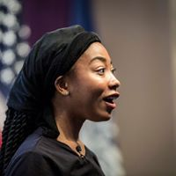
Odley Jean, performing Her Story, Uncut; Deka’s story

PANEL THREE: MEDICAL AND SERVICE PROVIDERS
This panel explored the role medical and service providers play and can play in Ending FGM/C. It brought together highly qualified and experienced Doctors in medical health. Dr. RanitMishori, an Associate professor of family medicine moderated this panel and was assisted by the following panelists;
- Comfort Momoh, MBE, founder and Director, Africa Well Women’s Clinic at Guy and St Thomas’ Foundation Trust.
- Dr. Marci Bowers, pelvic and Gynecological Surgeon.
- Dr. Crista Johnson-Agbakwu, OGBYN, founder, and Director of Refugee Women’s Health Clinic.
- Dr. NawalNour, Director of the African Women’s Health Centre, Brigham and Women’s Hospital.
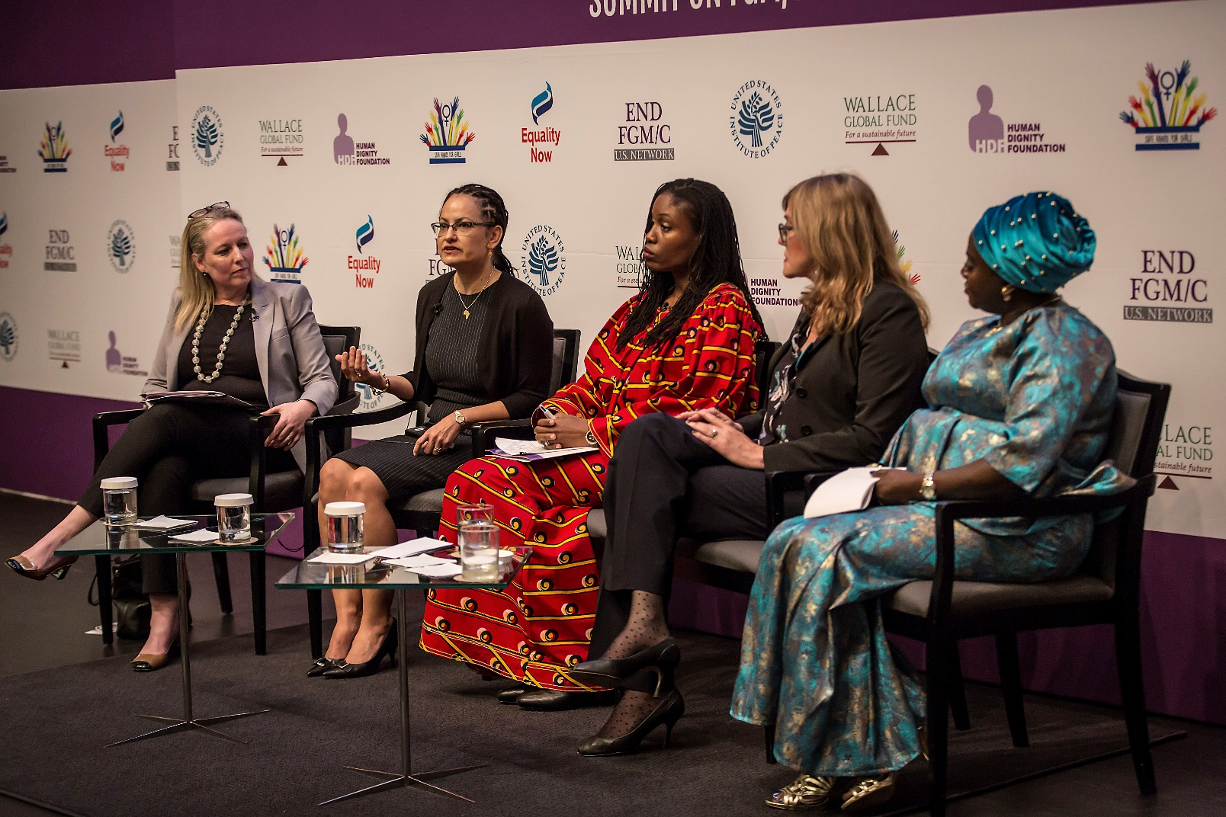
Panel discussion on the Role of Medical & Service Providers in ending FGM/C

Question
What are some of the challenges and opportunities for women and girls who have been affected by FGM?
Responds
- Dr. Nour
I started in the 1990s and the biggest challenges that I saw at that time was that health providers had no knowledge of or little knowledge of how to care for a woman that had undergone FGM/C and how to care for her during labor and delivery which can be very complicated. At that time, I founded and directed the African Women’s Centre in Boston and we really were working towards the curriculum and at that time I also used to work with the American college on obstetric, and gynecology to set a curriculum that can highlight how to provide culturally competent care. Majority of people will come up to me, I give them lectures, But first of all, how do you ask the question? Then I realized that the concept of having a woman who has undergone FGM going into a room with a health provider and the health provider herself/himself is so uncomfortable with the idea that they can’t even ask a question, and that’s a problem for us. We need to be able to have a very transparent conversation with people and one of the issues that I talk about is most of the women who have been cut are not uncomfortable. They’ve lived with it their whole lives and know how they feel. They just want somebody to ask them questions gently and appropriately and not be judgemental. That was one of the biggest challenges at the time.
Question
You work for the population in the context of the community, can you tell us about the challenges and opportunities for this kind of work?
Responds
- Dr. Crista Johnson-Agbakwu
For the past eight years, I have founded the refugee women’s health center in Arizona which is the only safety health hospital in the state. We serve a very large refugee growing population. Those affected by FGM/C are mostly East Africans, maybe Somali is the largest population that we serve. One of the most important issues is really establishing trust and often there is a disconnect between the health care systems and the communities and one of the vert first things that we sort out to do in Arizona was to really become embedded in the community. From the very beginning we thought to really mirror that and emulate that in building trust with the communities so that we can break down some of those barriers between providers, the health care system, and really being responsible to the needs of women. What I do in terms of teaching and training medical students is really conveying the critical importance of building these partnerships and relationships with the community and that really is grounded in trust because when you can take a holistic approach to engage women and leaders who can be the liaison between the health system and the community which is so critical. Women who are multi-cultural and bi-lingual are important in building empowerment, supporting women’s health leaders, tackling holistic issues that women face, not just FGM/C but also issues of acculturation, navigating healthcare systems, making sure that we have appropriate language interpretation, making sure that we can address some of the education gaps and women who may not have had the opportunity to learn about their bodies, about reproductive health, and to empower them to be able to make informed decisions about their bodies, and medical decisions that affect them and their children. To me that’s very foundational in terms of really ensuring that we are reflecting the need of the community, as well as displaying cultural humility, because though we may have the medical knowledge, our patients are the best teachers of their culture. I really that having a cultural humility, that we remain open to learn, recognizing that there is a spectrum of perceptive around this issue and making sure that we are not judgmental in terms of our approaches, whether it is with her verbal communication, or even our body language. They all have profound effects on our patients
Question
What are some of the challenges and opportunities you face as someone who conducts reconstructive surgery?
Responds
- Dr. Bowers
This procedure started in Paris in 2004 and more than 4000 surgeries have been conducted over the years. In 2007-2009 I started learning the functional and not just dividing the infibulation. In Saint Francisco, we do this without charging the patients and we’ve done approximately 250 of these. It absolutely works. There is such gross misinformation in lack of knowledge about the clitoris and actually what the damage of FGM is, and how the reconstruction works.
Question
Can you tell us about what worked in terms of the health care organizing in the U.K?
Responds
- Comfort Momoh, MBE.
We are a ahead of US in terms of health care organizing because I remember in 2014, I was here to do a scoping exercise to know where you guys are in terms of health care organizing. In the U.K what we do is to identify women as early as possible which is very key, and like Dr. Nour said, to ask a question is very challenging to professionals so it is very important that professionals know how to sensitively ask the question. Once you’ve identified the question, you need to provide a holistic care which is very important. As a professional, you need to put yourself into their crying shoes, and treat them the way you want to be treated. For me the challenging thing back when I just started is seeing professionals like me supporting FGM. But we have moved a long way now. There is still lot to be done, but we have moved. We have the support of the media, we have given the platform to the survivors to come out and tell us about their stories which are very powerful. Also, we now have the young people talking about their experiences and coming forward to say enough is enough. Again, in terms of replacing the clitoris, we still need to look into.
Question
Can you briefly talk about the global medicalization of FGM and if FGM can end by 2030?
Responds
- Dr. Nour
I hope FGM is eliminated in the next five years. The issue that I see in Egypt is that the medical community is not doing enough. The WHO has stand down on these by releasing statements saying as medical communities we need to refrain from the act. We need to get everyone on board and to think that medical providers are not on board is atrocious and we need to stop that.
PLENARY
- PARTICIPANT: (Bimbo) I did not get the part where it was mentioned that be it type one, two, or three, the clitoris is still intact. Can I please get a clear information on that?
Responds
- Dr. Johnson
There has been a recent study published at the World Health Organization last year that is fully grown breaking because she conducted pelvis amoral of women both cut and uncut to examine the clitoral tissue and what she found was that 100 percent of these women have their clitoris completely intact and comparable to women who are uncut. We however need to look at multi-disciplinary approaches to addressing sexual functions holistically in women by involving sexual and physiological therapy and counseling using validated instruments that are tested based on sexual functions.
- Dr. Bower
The operation still does require some sort of procedure but it is settled that if the clitoris has been damaged, the suspensory ligament needs to be released so the clitoris is brought down otherwise it will retract behind the scar tissue. It is the scar tissue and covering of the clitoris that does the damage. In FGM less that 10 percent of the clitoris is removed. We know this because if it is more than that then there will be arterial bleeding
- Dr. Comfort Momoh, MBE.
We need to know that it depends on what has been damaged initially so one needs to address that as well.
- PARTICIPANT: We are talking about violence against women and girls and within that context I want to know what the OGBYN and other medical professionals and their opinions on vaginal rejuvenation clinics? We are hearing increasingly that several non-African girls are getting mutilated
Responds
- Dr. Nour
Vaginal rejuvenation I think is a very interesting terminology. It can be very bloody and it can create a lot of scar tissue. The data that comes out of it is not very clear as to whether women that come out of it are indeed feeling any better. The aftermath can be very painful and I think it’s a very great marketing technique. The issue on the US of course is that anybody over the age of 18 can do anything they want with their body so we as a medical community can say that they are loose and want to be tightened. This is not just Africans, not Americans or just Latinos. It is the continuous message that gets sent to girls and women that I think is the problem.
- Dr. Comfort Momoh, MBE.
I think its double standards because on one hand it is okay for the west to have their labia trimmed and on the other hand it is not okay for non-west to do the same.
- Dr. Johnson
There is indeed a double standard and I do have a small percentage of my patients who define their beauty by retaining their integrity and these are women who say that the lens at which they view their body is what’s beautiful.

VIDEO TRAILER: JAHA’S PROMISE
Thank you, ladies, and gentlemen. I come from a journalistic background and at some stage we as journalists in the west realized that it wasn’t good enough to just report on FGM. The problem was soo urgent and drastic that we had to take further steps and those steps were to share our tools, social media, film making and to work with the grass-root activists, the big sisters as we see them to tell them to take control of the media, radio and broadcast in your local communities. We also realized that TV and stories are important so we made this documentary with Jaha which follows the story of one of the Big Sisters, and we really genuinely believe that this film can go in all the countries where FGM is practiced, it can go out in prime-time TV, and it can help break the silence.
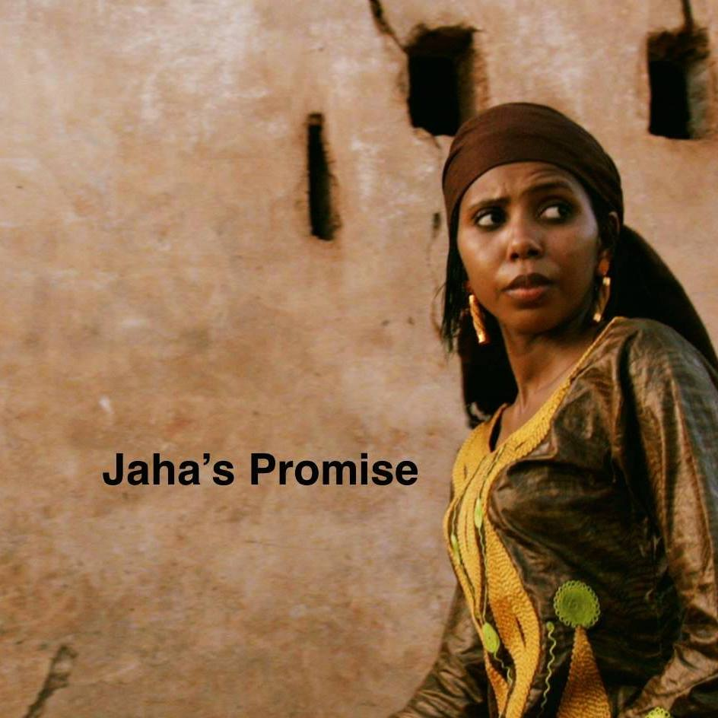

PANEL FOUR: LAW ENFORCEMENT & CHILD PROTECTION
This panel discussion brought together lawyers and law enforcement officers, well-grounded activists who are well experienced in activism and are equipped with the ability to dilate on topics especially related to the legal frameworks relating to violence against women and girls both locally and internationally. This panel was moderated by Susan Masling, Attorney, U.S. Department of Justice. The panelists are as follows:
- Kathleen O’Connor, Deputy Chief, Human Rights and Special Prosecutions Section, Criminal Division, U.S. Department of Justice
- Christine Nanjala, Assistant Director, Director of Public Prosecutions Office.
- Maria Saine, Programmes Manager, Safe Hands for Girls, law graduate.
- Gerry Campbell, former Detective Chief Superintendent, Scotland Yard.

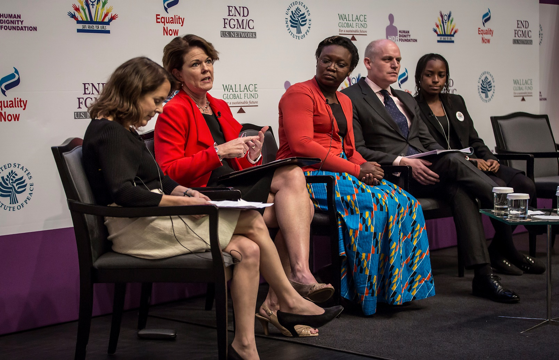
Panel discussion on Law Enforcement and Child Protection

On her part, Susan expressed that it’s a great pleasure for her to be in the summit and to see so many friends and new acquaintances and to be on the stage with such distinguished guests. She then gave a brief introduction of her panelists and went straight to the questions.
Question
Within the department of justice, HSRP has been holding round tables in cities around the country including New York, Miami, Chicago and other cities. Who comes to these round tables, what’s happening and is it working?
Responds
- Kathleen O’Connor
The inter-agency within the United State government has identified FGM as a critical issue that needs to be dealt with. We have a federal law that criminalizes FGM and in an effort to ensure that people understand that there is a law that criminalizes FGM, we have engaged with U.S. Attorney’s offices in regions and cities were large populations are at risk or where girls and women reside. So the U.S Attorneys offices have convened round tables to educate and to facilitate networks. We invite to these round tables professional who work with immigrant populations, professionals who are law enforcement, professionals from child protection services, education, and medical community, to come together and educate on what is FGM, what are the complexities of FGM, why does the U.S care, how does it affect the U.S population, and we engage with them to educate and to encourage them to start networking locally to address the problem.
Recently we convened a group in Brooklyn, New York. After the meeting, the group organically came together and started networking amongst themselves. They will hold their second meeting by themselves organically next week and this is all different sides of society, both NGOs, federal, state, and local officials, child protective, education, and law enforcement all coming together to holistically address the issue and to figure out what they individually can do to stop FGM. It is working. For example, the mayor’s office in New York is looking at a public relations campaign where they will have on the subways and buses, signs that will say “STOP FGM”. This is just part of the results that have come from the round tables.
Question
Christine, you head a team of twenty prosecutors and you have many investigations and cases prosecuting cutters in Kenya. Can you talk about what has been working within the department of public prosecution to help you achieve that?

Responds
- Christine Nanjala
If I must talk about that it will take the whole day. Kenya has moved a long way in terms of implementing the law against FGM and in terms of civil society advocacy. For us, we’ve reached the point where we are talking about implementation. Advocacy, implementation of the law, and tying it all together to bring us to a point of abandonment of FGM. At the Director of Public Prosecutions office, what we have done and what has really worked for us is engagement with the real stakeholders because we must realize that we are at a point where a multi-sectorial approach is what is required for us to move to an abandonment of FGM. We can talk about the donor funding, but at the end of the bad, silent mentality does not work. Each sector needs to come together. Government needs civil society and civil society needs government. The networks that we are building on the ground is what is going to propel is into ensuring that this is done.
On an overview, we’ve handled seventy-nine cases so far. Out of the seventy-nine cases, we’ve secured ten convictions with the highest being a seven years’ sentence in Kenya. We have faced several challenges in terms of implementation of the law and all these challenges arise from the communities itself and that it where the civil society then comes in for us because we need witness to prosecute our cases and secure convictions. Without the witness, there is not much we can do.
In Kenya, we also have the Anti-FGM board and the chair of the board is here with us today. It is a state organ just like the office of the Director of Public Prosecution and we’ve got various civil societies represented here like The Girl Generation and the reason why we are here is for us to work together towards ending FGM. The DPP has played a pivotal role in terms of implementation of the law and we will not stop prosecuting. So, civil society, please join us and find out what you’re going to do to the children who are coming out as a result of the prosecutions because we’re still going to put people behind bars. It is working, it can be done, it is just one of the tools.
Question
Gerry, over the last several years, the British government has a whole government approach to try and eradicate and prevent FGM/c. Can you talk about how this has worked in terms of investigating?
Responds
- Gerry Campbell
I will absolutely start by saying that Female Genital Mutilation is a crime; it is one of the severest forms of child abuse, and it is a fundamental abuse of women and girl’s human rights. But the significant part of this is about the bunking and demystifying of some of the unknowns, the superstitions and the myths which surround the subject. There has got to be what I will call the honesty of the conversation, but the key part of that is how we deliver the honesty of the conversation in an honest, transparent, open but understanding way which is non-judgmental. The U.K. approach is about collaboration with partners, it is about the mutual understanding and respect we have with the non-profit organizations many of which are here from the UK in the audience. It is about partnership and about prosecution but we need to be clear with the fact that when we start talking about prosecution, it means that a girl has been mutilated and cut. It means that a girl has sustained a very severe graphic injury whether it is physical and a combination of psychological. We must absolutely work together to prevent, protect and safeguard in the first instance but of course arrests and prosecutions are important as well. They are important because they send a clear signal to victims and potential victims around empowering them to come forward. They will be believed, they will be supported, but it sends a clear signal to perpetrators and potential perpetrators. We want to be able to disempower those perpetrators. But also, key to this is what we call community driven solutions. If we really want to eradicate FGM by 2030, the real true solutions must come from those affected communities which undertake the practice.
Men also have a fundamental role to end the practice so there is something in there for me about the Big Brother Movement that must compliment and support the Big Sister Movement as well.
Question
Maria, as a law student that has been very active in the campaign to end FGM, can you tell us what technique you’ve found most effective in mobilizing community support and government support for your efforts?
Responds
- Maria Saine
In The Gambia, the most effective strategy that we used was putting the youth in front because as youth we have an authentic voice that everyone can hear. So, in The Gambia the campaign to End FGM is mostly youth-led, notwithstanding we have institutions and organizations that have been working on ending FGM for the past three decades but because the campaign is youth-led, we had our voices heard by the government and the communities as well but even though we had that in place we also needed certain strategies that we could use to convince the government that FGM should be banned. So, for us at Safe Hands for Girls, one of the strategies we used was by having an MOU with the Ministry of Health and Social Welfare and through that we were lucky to have a land from the President. Through our communication with the Ministry, we were lucky to pay a visit to the President at his native village. We had a honest discussion with him and in less than a week, he banned FGM in The Gambia. From there I could tell that what he needed was an honest conversation with the youth. So, with this it is evident that the youth need to be in-front. When we go to meeting, the youth we in the menu, its high time we are placed on the tables too to further encourage these honest discussion.
Question
What are the biggest challenges standing in your efforts to end FGM/C?
Responds
- Kathleen O’Connor
In terms of the United States, we are behind the efforts of the rest of the panelists here. We have a lot of catching up to do but fortunately we have leader up here and others in various countries who are really forging the way for us and so we are learning from that. We are taking the work that they have done and looking to implement that in our work to prevent and respond to FGM. That’s one of the challenges
Another challenging is knowing how many girls are affected by FGM in the United States. The CDC came out with study and said the five hundred thousand girls and women in the United States are at risk or have been cut. Those are extrapolated numbers however, so they are based on extrapolation and not on actual evidence from individual females. Knowing how big the problem is, where it is, how it affects girls, who does it, where it’s done, and why it’s done, all of this is information that we still need to collect. Mandatory reporting will be extremely helpful and that is something that we are working on. We are working with the inter agency and with the local and state law enforcement and child protective services, education, and medical services all of which we are trying to pull together and get networks. But the United States is vast and we are not just dealing with one cultural practicing FGM, immigrants to the United States come from all over the world and the complexity of FGM by society is very different. We are trying to educate ourselves, and educate others but it’s a very big challenge. A lot of passionate people who are working on this issue, we have leaders to follow in their footsteps and I am confident that the progress we’ve made in a very short period which is about two years will be built upon.

- Christine Nanjala
For me this is how I look at it, speaking from a prosecutorial point of view. When I joined the office of the Director of Public Prosecution, I thought my work will just be pushing files. When I close a case, am done. Never have I imagined that I will be dealing with matters of FGM. So, me the biggest challenge is us and our inability to think outside the box. These are issues that are here with us but for every law and every problem that is there, there is always a way that is around it. Can we get outside the box and let the box fit outside the circle and look at it because what we have done I think has never been done in the history of prosecution in Kenya because no prosecutor has gone out of his or her office to engage the public in dialogue. It does not happen and very rare will you see it happening. But they is always a creative and innovative way of dealing with every situation that you face. We need to get above ourselves and look outside the box that way we will be able to eradicate this by 2030. We are the challenge and we should do it better.
- Gerry Campbell
We’re not going to legislate, arrest and prosecute our way out of this global problem. The real challenge is about education, education and education. The coalition of partners and law enforcement must work hand in glove with prosecutors. Law enforcement and prosecutors must work hand in glove with non-profit organizations and all those actors within this global battle must hand in hand in partnership with affected communities to identify the sustainable solutions for change.
- Maria Saine
For me without prejudice to the fact that we have the laws in place, as an activist, the greatest challenge I have is the law itself. As an activist, I will rather tell people why the law is there in the first place that tell them than telling them the consequences of breaking the law or subjecting someone to imprisonment. It is always important that you create awareness and having the law is important for our advocacy but the when it comes to community outreach, it is important that we focus on the health effects and why people should stop the practice of FGM and why the government has come on board to ban FGM. So having that in place and going to communities and tell people that if you do this you go to life imprisonment I think that’s the wrong approach. It is important that we have it and it should be used as a last resort but there are other measures we can focus on that can help us end FGM by 2030. That the challenge that I have and I encourage everyone in this room to focus on awareness raising and use the law as a last resort.
PLENARY
- Mam Lisa Camara(Participant)
The current case in The Gambia, what is happening and what do you think is going to happen next. The old woman that is in mile 2 that is still in prison without judgement. Can you help us with where the case is as of this moment?
Responds
- Maria Saine
I think the case had gone a long way. It was at the point of judgement but on that day the defence counsel failed to appear in court. The situation right now is that even though we have the law in place, even though we continue prosecuting people, my position is that it doesn’t only need to continue, but it need to accelerate and that is where The Gambia is failing now because this case should have been put on judgment a long time ago but they keep delaying the case. The woman is in prison and they are not doing anything about it. The child is dead and they promised to conduct a post-mortem but they still haven’t done that and that’s the reason why the case is still holding and now I don’t think they are willing to let the woman go even though she’s entitled to certain rights but because of the current judicial system in The Gambia she’s not being allow to come out and voice her own opinion in her current situation. What she did was wrong but she needs to be heard. We cannot take that away from her.
- Anitta Koroma(Participant)
In our own case in Sierra Leone, we are having a whole lot of issues. We have well written laws but there is no enforcement. As activists, we are still struggling. Recently we had two cases, a nineteen-year-old died, and the minister of social welfare took up the case bringing out some post-mortem results that we’re not satisfied with but we cannot challenge because we are limited. What is your advice because there is nothing like political will for them to come on board and say yes, we are going to do it? Understand your system and then get strategies from your system on how you can deal with it
Responds
- Maria Saine
If your situation is that bad, then my advice is that you should test your laws. In The Gambia, before FGM was banned we should have been able to test other law that relate to FGM. For example, laws relating to discrimination, assault could have been used in the courts to label FGM a crime. Personally, I cannot tell you that this is the way that you should go in terms of Sierra Leone because I do not know your judicial system, I do not understand your laws. If need be, have a sitting and look at all your laws, understand your judicial system, understand your political system then we can see something
- Christine Nanjala
Just to echo what Maria is saying. I’ve had this discussion with her before in our office at one point. Look at your laws in totality because one of the mistakes that we normally di is that we isolate FGM and you look at FGM as a single act. But when you start looking at the totality of FGM you can see that it touches on various spheres of life. When you go to the bill of rights it fits squarely. We’re talking about the right to life, the right to health, the rights of the child, it fits in squarely in all that. In Kenya, we have the penal code, in Sierra Leone you might have something similar like that. There are offences in there that where FGM will sit and sit pretty. We’re talking about the offence of assault, the offence of grievous bodily harm, those are things that are in the laws that you already have. My advice to Maria was, can you test your laws and my advice to you is, can you test your laws.

- Mariatou (Participant)
If FGM is a global issue, why can’t we have an international law to carry on everybody?
RESPONDS
- Christine Nanjala
It is available. In various conventions and in the United Nations Resolution.
- Kakenya Ntaiya(Participant)
In Kenya, we are doing a great job in terms of implementing the law on FGM and making sure that the people who are practicing FGM are prosecuted. I however find myself in a very hard place where we rescue girls that have been cut, then their parents are taken to the police station. There are no proper places for the girls that are already bleeding and taken to the police station. There are a lot to complicated issues surrounding this. What is out there in Kenya that can help me?
Responds
- Christine Nanjala
To answer your question, I understand ad I know of the issues where the girls were taken to the police station and the issue nearly cost me my job. One of the things we are telling our prosecutors within the counties is that, it should never happen again. We tell the networks that bring the girls to us that the first stop for every girl that has undergone FGM is at the hospital and that is what is happening right now. This still take me back to the importance of a multi-sectoral approach of coming together and working together. If you call me and tell me that you have a girl somewhere and something is happening, I will raise the county commissioner, the police, the Anti-FGM board to make sure that they can raise someone in civil society who can look after the girl. We always follow up most of the cases and we ensure that if there is need for the girls to be committed into a home, we ensure that they get committed into homes.
However, we also need to start thinking of having community protection structures because we are having problems in reintegrating girls once we remove them from the communities. I don’t advocate for the institutionalization of children. I believe that children are better placed within the community. The system is not perfect but we have done the best that we can do.
Question
- Hawa Trawally (Participant from Sierra Leone)
Why don’t we set up laws that govern all nations that are involved in the movement because in my country there is no law governing FGM.
Responds
- Kathleen O’Connor
To have a law, you need to have a court that has the jurisdiction over that law and we don’t have that. We have certain courts that have certain jurisdiction over certain crimes but there is no international court over the over the crime of FGM. We do look to national prosecutions and national law enforcement to implement or execute national laws. The voices in this room, the NGOs, the activists, like Safe Hands for Girls and Equality Now, these are the organizations that can really be the voice and frame the issue and push the agenda to make it an international effort to End FGM but the national prosecution only has jurisdiction over certain place, certain persons, and certain crimes.
- Maria Saine
To add to what Kathleen has just said, I am not particularly sure if Sierra Leone is a dualist or monist state but we have international conventions that can be signed, ratified and domesticated by your state. If not, there is a principle in international law that if you have exhausted all local remedies in your state then you can go to the international court. So, it is all part of using the options available for you to seek justice. If your courts fail to listen to you and to fulfill your rights, then you have the right to seek justice in the regional or international courts and that is the African court of Justice for you. But this also depends on how you frame your issues. But back again, what is the legal framework of your country? You have to understand it, you need to understand the politics and how to go around it. So, it’s all strategies.

PANEL FIVE: RELIGIOUS AND COMMUNITY LEADERS
This panel discussion brought together well-grounded scholars who are well versed in their various faiths Iand are equipped with the ability to dilate on topics especially related to life and well-being of women and FGM in Islam. The panel was moderated by Manal Omar, Associate Vice President, Center for Middle East and Africa, U.S. Institute of Peace. She was assisted by the following:
- Pastor Emanuel Bamba, Vice commissioner, Conakry World Book Capital North America
- Imam Baba Leigh, Prominent Imam and cleric that has worked on issues of FGM for decades
- Arsalan Suleman, Acting U.S. Special Envoy to the organizations of Islamic Cooperation, U.S. State Department.
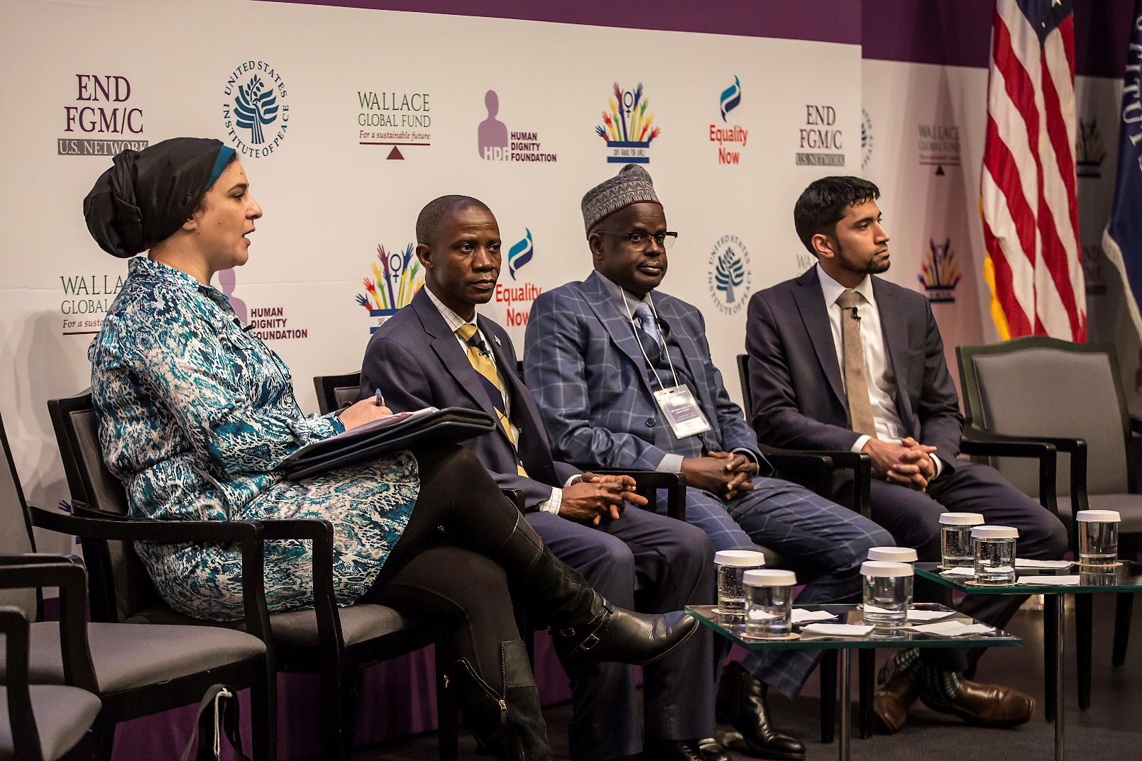
Panel discussion on the role of religious and community leaders in ending FGM/C
The last panel really set up this panel well in terms of us getting outside of the boxes, we need to be innovative, and this means all hands need to come together whether its government, civil society, even the private sector. One of the things that we always ask ourselves is who hold moral authority? Who can really convince people on the streets in terms of communities about shifting change? Often it goes back to community and religious leaders as holders and part of the moral authority, the role can be very essential. I want to acknowledge that because it is not often that religious leaders and community leaders are involved.
Question
What do you see today as your greatest challenge in communicating the message on FGM/C?
Responds
- Pastor Emmanuel Bamba
I have still not been able to engage myself in the campaign to end FGM but thanks to my aunt I have now taken it upon myself to talk about the issue. Unfortunately, my mum and wife were circumcised but my fight today is to ensure that my children will not be subjected to the act. As a man and a community leader, my role is to talk about issue like this and when I go back to Guinea, my issue will be to talk about FGM. For now, I have no specific challenge because i.ve not yet been involved nut now I am committed.
- Imam Baba Leigh
Started by greeting in the name of Allah said, I have been involved in advocacy to end Female Genital Mutilation over forty years ago, When I was very young, my closest sister died because of FGM so I was naturally convinced that this cannot be right. The main challenge I’ve faced as an Islamic Scholar in communicating the message on FGM is religion and tradition. Most religious people today are not equipped enough to know their religion as they should. They are doing and saying it is the way we found our grandfathers doing it, that it is a tradition and it is a taboo to talk about it. Thankfully, the culture of silence is broken in The Gambia. In The Gambia, politically, it is banned, but knowing the third world countries, to have a beautiful and to enforce it is a different thing, this he said is also a another challenge.
- Arsalan Suleman
First, I think it is extremely important that we have men in this conversation because one of the main barriers that I still see is the lack of education about the practice and the lack of men speaking out and being part of the conversation. The efforts of religious leaders are also critically important because they have the authority to get across the message to their communities and to inform their various followers about the truth, and, the general guidance on health matters. If more religious leaders are educated on this then we can end the practice.
Question
In terms of the successes, what is the primary key that you’ve found in unlocking successes?
Responds
- Imam Baba Leigh
Most circumcisers do this as a means of living. Through the organization that I have worked for, one of the successes we’ve registered is by subsidizing these means and providing the circumcisers with alternative job opportunities.
- Pastor Emmanuel Bamba
Personally, the fact that I am sitting here is success. From here I can go ahead and do work in my community by spreading the message. Right I feel like this subject did not concern me but now I have interest in it and that’s success for me.
PLENARY
- Alimatou Dimonekene(participant)
What are some of the challenges you’ve faced when faith or religion is used when interacting on issues with deal with women?

Responds
- Imam Baba Leigh
So many people use religion even against themselves because of ignorance so like I said, lets continue to educate them.
- Mariatou Newlands
How do you relate to other religious leaders and have you ever attempted to engage other religious leaders in a conversation about FGM?
Responds
I have in so many occasions attempted to engage my fellow religious leaders in The Gambia in the issue of FGM and it eventually led my arrests in 2012 and also in 2013. My biggest problem is the religious leaders themselves so we really need to engage the religious leaders to make them realize that FGM is not only against the teachings of Islam but it is also harmful.

VIDEO: ADDRESS FROM THE RIGHT HONORABLE PRITI PATEL, UK SECRETARY OF STATE FOR INTERNATIONAL DEVELOPMENT
Honorable Priti thanked Shelby and Jaha for inviting her to make the address and apologized for not being able to make it to the summit. She said the U.K is firmly committed to ending FGM both at home and abroad and cannot and will not tolerate any form of against women and girls. She added that last year she announced an extra U.K aid package to combat the abuse of women and girls across the globe. This she said includes 40 funded grassroots working specifically to end FGM and child marriage. She went further to inform the participants that the home secretary hosted an FGM summit in London to reiterate the UK’s government commitment in tackling this unacceptable practice, a commitment first made by our prime minister at the girl summit in 2014.
She added that Change is happening, women who have been cut up themselves have decided not to cut their daughters. Since 2008, over 15,000 communities representing some of the 17 million people have made public commitments to end the practice. 13 countries have enacted criminal legislations against FGM and 14 have policies or frameworks that help in tackling the practice. But progress is not fast enough and current funding levels are not sufficient. To end FGM in a generation, she advised that more political commitment is needed, more money and, more action. FGM is a form of violence against women and girls and one of the most extreme manifestations of gender inequality. She urged the participants not to relent in their efforts to tackle the problem. Only when we live in a world free from FGM will all girls be able to grow off free to fulfill their true potential. She then called on each every one at the summit to come together, to continue to rally behind the Africa-led movement to end FGM both globally and within the United States.
In her conclusion, she emphasized that whether one is a funder, a policymaker or making a difference on the ground, each and every one has all have a role to play.

PANEL SIX: INTERNATIONAL SUSTAINABLE DEVELOPMENT GOALS
This panel was moderated by Lyric Thompson, Director of policy and Advocacy, International Center for Research on Women. It convened great minds that have worked on the continuous support for the full realization of the SDGs. The panelists were as follows:
- Susan Markham, Senior Coordinator for Gender Equality and Women’s Empowerment, USAID.
- Dr. Morrisanda Kouyate, Executive Director, Inter-African Committee on Harmful Practices.
- Nafissatou Diop, Coordinator, UNFPA-UNICEF joint programme on FGM/C
- Mary Wandia, End FGM Programme Manager, Equality Now.
- Dr. Faith Mwangi-Powell, Executive Director, The Girl Generation.
To begin with, Lyric introduced the members of the panel and went straight to asking questions.
Question
What is the biggest challenge with the new Sustainable Development Goals and how can they make a difference?
Responds
- Susan Markham
At USIAD, we think of the SDGs in two way; first of all, we are part of the US government’s work do develop our strategy on how we work on the SDGs and then we really looking to the countries where we partner and our work to help them implement the SDGs in their country and be able to report about them. I think one of the challenges of the SDGs is that the 17 goals and the 169 targets is such a he number and finding ways to focus ourselves on some of these is going to be difficult. I however think that with FGM/C, and the other traditional harmful practices, if we can focus and end some of those, it underlines many others.
Question
When did the terminology, harmful traditional practices come forward and what do you think of goal 5 in terms of FGM/c?
Responds
- Dr. Kouyate
The term “harmful traditional practices” is history in the fight against female genital mutilation. In 1984, February 6, in Dakar, we gathered some African countries together and with the support of the international community we decided to start up an organization that can fight against Female Genital Mutilation. This turned out to be a very big challenge because it was hard to talk about female genital mutilation. There was a very huge and strong apposition against the campaign. Because it was hard to talk about it back then, we decided to involve everything in one package and call it harmful traditional practices. It was a strategy that we used.
Question
How is your organization and effort doing along the path of the SDGs?
Responds
- Nafissatou Diop
There has been a lot of work and people recognize that FGM is not only an African issue but it is also a global issue. After so many years of implementation of the programme, and seven years of supporting civil society organizations, governments, networks, media, and having done a lot of efforts the main challenge been the cross fertilization between all the different countries and experiences that are out there. People have been working for years and we have created a lot of relationships with religious leaders and medical providers. We need to recognize what has been done already and keep educating ourselves.
Question
What is the biggest challenge you are facing right now in your work?
Responds
- Dr. Faith Mwangi-Powell
It is exciting to be part of this and for that I wouldn’t even look at the challenges but rather the challenges. When I think of the SDGs, I see them as an opportunity and not a challenge. The UN resolution gave us a mandate and it is what has been carrying us and giving us the credibility to even talk about FGM. It is our responsibility to hold our governments accountable.
- Mary Wandia
As faith said, challenges always come but if you flip them, they become opportunities. I see the SDGs simply as a framework and being frameworks that are not legally binding, then the issue is enforcement. The critical element that is required is the political will. When the government is committed, they develop action plans and then they monitor the progress. So, the challenge I have with the SDGs is how will they be translated into actions and how will that action translate to me in protecting more girls from FGM? That the challenge I have.
PLENARY
- Raymond Ukwa(Participant)
In Nigeria, UNFPA only focus on five states, is it possible for your team to extend beyond these five states?
Responds
- Naffisatou Diop
We conducted a study and we considered your concerns. We need to think about the means and in addition the human resource. With those six states, I believe we have a long way to go.
- Raul Jacob(Participant)
What are the challenges of implementing sexual education that has some elements of the health hazards associated with FGM within academic curriculums at the private sector?
Responds
- Dr. Kouyate
I think it’s more about starting with the younger generation and educating them about the consequences of Female Genital Mutilation and they will grow up with that. We however have different types of education. We have the formal education, and the traditional education which is at the grass-root level. Both needs to be done together to achieve the goal.
- Mary Wandia
In terms of inclusion of sexual reproduction health in schools. Mary added that the rights of fundamentalism be it religious or traditional plays a part and when most civil society organisations call for that, you either see the traditional leaders or the church come up and say that we cannot teach sexuality education. This she said remains a challenge but in terms of FGM, she reiterated that there has been advances with most countries introducing education on the effects of FGM and how young girls can protect themselves from FGM. We also have groups integrated in the communities that reach out to the cutters by training them on the impacts of FGM but we also need to be realistic that we also have that obstacle where sexuality education is still seen as an area that shouldn’t be touched.
- Aissatou Sey(Participant)
What is the promise you have for us today to encourage and motivate us for the job we are doing to end FGM?
Responds
- Dr. Faith Mwangi-Powell
At The Girl Generation, we are galvanizing the global movement to end FGM so if you can join the global movement, you will be inspired and you will know that you are not alone.
Question
- Mary(Participant)
What role do you think regional organizations that already inter-face dialogue can incorporate your work into what we are doing in terms of trying to dispel myths about FGM and the surrounding religion?
Responds
- Susan Markham
I suggest you hold your government accountable on the issues you care about, help collect data, and organize programs that will help the countries meet the SDG goals,
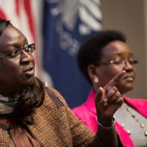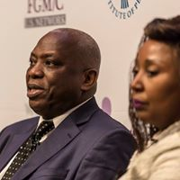
Faith Mwangi-Powel, Mary Wandia, Dr. Kouyate and Naffisatou Diop during the panel discussion.

CONGRESSMAN JOSEPH CROWLEY, U.S HOUSE OF REPRESENTATIVES
It is an honor for me to be here in the Institute of Peace. I want to thank everyone for participating here today. I want to thank Equality Now for what it has done in bringing attention to FGM and trying to find a way towards ending the practice throughout the world including here in the U.S. You have been such a leader in this issue and such a resource for me and for my staff as we work to end FGM for all girls everywhere. There are so many leaders here I would like to recognize but I would use up all the time that I have as this is truly an all-star lineup that you have provided here today.
I also want to thank the Wallace Global Fund, Human Dignity Foundation, and once again the U.S Institute of Peace for all your contributions to this tremendous event today.
But let me single out one very special person here today for her recognition. She’s one of the most compassionate fighters to end FGM and really one of the most compassionate fighters in general that I have ever met and I don’t even want to look at her because she gets me emotional. I have a 16-year-old girl, if anyone ever did to her what Jaha and others have had to go through, I wouldn’t be a peaceful person. You don’t have to tell me how wonderful Jaha and Safe Hands for Girls are because I know you already know that, but she continues to motivate and inspire me to do better and fight harder every day. Jaha and I know how much work all of you from Equality Now have done to make this event a so special and important. By bringing the best and brightest minds on this issue under one roof, this summit shows just how much the U.S and the entire international community are serious about ending FGM in this generation. FGM is an extensive problem so it needs extensive solutions. We need to approach ending FGM through laws, education, outreach and through trusted leaders in our community. Many of you know that I first came to know about a dangerous loophole in U.S law that allowed girls to be taken oversees for what is known as vacation cutting. These girls may have been living in the United States where FGM is illegal, but they were being taken out of this country to become victims of FGM with no protection under U.S law. Si I sponsored the girl’s protection to make it a crime to throughout the country for the purposes of receiving FGM. The basically says if you take a girl outside of the United States, for the purposes of FGM, you’ll get the same penalty as if that was performed here in the United States through your allowance. The girls protection Act was about putting the law firmly on the side of girls and when it became law in 2013, it brought the U.S. in line with what the European countries had done to protect girls travelling abroad. This law primarily acts as a deterrent knowing that something is against the law will provide an important cent for people to turn around from the practice of FGM. But beyond the law, more needs to be done here in the United States and globally to urge people to voluntarily reject FGM and that is why I am so pleased to work this broad community of advocates to energize leaders to fight for such an important cause.
I firmly believe that ending FGM in a generation is an achievable goal. It may be a challenge, but it is one that we absolutely must rise to because we can effectively make this happen. I come not just as a member of congress but as a husband but also as a father of a 16-year-old girl. No girl should have to go through FGM. Not here in the United States, not anywhere in the world. On the international scale, I was so pleased to have FGM included in the Sustainable Development Goals because it will make a big difference in how the world responds to FGM. I encourage my colleagues to join me and urge the United States government to lead in including a global indicator for FGM in these goals. It also reminds us that FGM is not just limited to one culture or one region. Here in the U.S. I have introduced legislations that will lead to a national strategy to fully address FGM in our own country. We need prevention, and intervention from that fully addresses FGM, and we need a comprehensive approach to find a solution such as raising public awareness, especially in communities where this practice is prevalent and an emergency hotline to help at risk girls and their allies. We also need to arm our children, law enforcement officers, and medical professionals with the tools and resources they need to help at risk girls. FGM is not a simple problem; it intersects with a wide range of problems including health, education, law and justice, immigration and travel, and a foreign policy. I know that some of our UN agencies working on these issues are represented here today. I want to thank all of them for the work that they are doing, and to encourage them to keep that up. We all have a role to play so thank you to all the advocates for holding our feet to the fire. Even with a change of administration, even with so many pressing needs worldwide, we cannot let this issue be overlooked. Please keep pushing us, keep pressing us to do more and do better, keep reminding us of what we are fighting for. I am sorry that I couldn’t come for the whole day, but I am glad to speak just ahead of the panel about best practices and solutions. I am so glad that they will wrap off what we can do to end FGM. So, before I turn this back to Shelby, I just to say that I will never stop fighting on this issue. I am proud to have the opportunity to be in congress. This is the kind of issue that helps me be a better person. I will keep working with anyone, and I mean anyone who is willing to join us in this fight. Working together, I know we can make a difference.

PANEL SEVEN, BEST SOLUTION AND PRACTICES
The members of this panel were also members of the planning committee behind the summit and reinforces the importance of a multi-sectoral approach in ending FGM. The panelists had different groups that developed best practices and solutions for each sector. These groups were represented by;
- Jean Smooth, Senior Counsel for Policy and Strategy, Tahiri Justice Center, representing the law enforcement and child protection group
- Mariam Diallo, African community specialist at Sanctuary for Families, representing the state
- Rachel Clement, Policy Advocate at the International for Research on Women, representing the foreign policy group.
- Ranit Mishori, Director of Global Health Initiatives, Georgetown University Medical Center, representing the healthcare group
- Angela Peabody, Executive Director of Global Women Peace Foundation, representing the education group
- Nina Smart, Founder of SWF International, representing the immigration group
- Jaha Dukureh. Founder and Executive Director of Safe Hands for Girls, representing the activist group
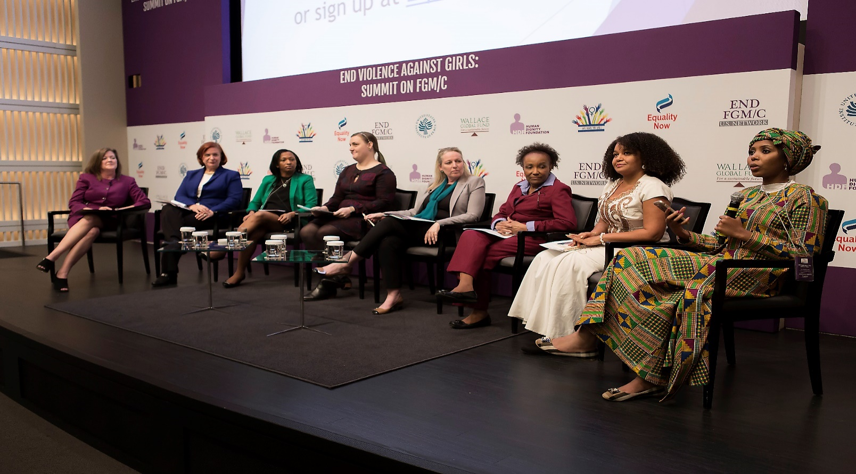
Panel on best practices and solutions
RECOMMENDATIONS
JEAN SMOOT
- Laws should be used as a tool in advocacy because we cannot legislate, arrest, or prosecute our way out of FGM
- FGM needs to be recognized and classified as child abuse by federal state local state officers.
- FGM/C is a form of violence against women and not just girls and it needs to be recognized in every program, office, department and grand funding stream that handles violence against women and if it is not recognized then it should be legislated within the violence against women Act.
- Law enforcement needs to work with at risk communities and the focus needs to be on education, risk assessment and prevention.
- The education and outreach should likewise be coordinated with community groups, and focus on the harms of the practice, the laws that are available, and also to help individuals to exercise their rights and available support services.
MARIAMA DIALLO
- To encourage people to come up with working groups by making it very diverse so as to split the work. This she said, creates expertise.
- Outreach and education. Service providers need to know their reporting obligation and review every clinical assessment they have.
- Involving the youth.
RACHEL CLEMENT
- Implementation of the various policies available and coordinating them in the different agencies that have implementation plans.
RANIT MISHORI
- The need to educate health care providers around the country regardless of specialty and create a curriculum that addresses all the issues from the direct medical care to methods of communication, to ways of screening in such a way that is non-judgmental.
- There needs to be multi-sectoral collaborations
- Extensive research on FGM needs to be done
- Community based collaboration so that everything is anchored in the communities.
- Advocacy within our professional organizations

ANGELA PEABODY
- The U.S Department of education to develop and disseminate FGM educational and training materials to schools, universities, the diaspora community groups, health care professionals, police and others.
- The U.S. Department of state to fund educators to develop programs that engage the diaspora communities and help train young leaders, both boys and girls to speak up against the practice of FGM
- An educational toolkit to be developed and distributed to every school district throughout the united states.
- To develop an application for FGM/C that works great for young people
NINA SMART
- Increase distribution of information about FGM/C through existing channels of immigration
- Increase distribution of information for refugees from the countries where high prevalence rate occurs. This has to be culturally sensitive and situationally appropriate.
- Engage with U.S located embassies and consulates all over the U.S. and with countries having high FGM prevalence to raise awareness and send information to their nationals.
- Encourage the U.S government and civil society activities to educate and raise awareness throughout these events and using people who have trusted relationship with the community.
JAHA DUKUREH
- Donors to trust grass-root activists in terms of program structure and funding flexibilities in their countries.
- For everyone to start looking At FGM not as a stand-alone issue but as a form of violence against women and girls that cannot be solved unless it is integrated with other issues it is linked with like child marriage
- Model Replicas
- Making sure that the movement is sustainable
What needs to happen in 2017 to get us closer to our targets
JEAN SMOOTH
- We are going to continue doing the work and think creatively and figure out how law enforcement can create clarity about peoples’ rights, and to figure out how we can come out with something concrete for collaboration.

MARIAMA DIALLO
- We are going to create a standardized training tool that will target the medical, educational. Law enforcement and the social services. For each sector, we will have a specific training tool
- We will come up with two pages of information on FGM/C that we will distribute to many service providers including doctors and nurses.
RACHEL CLEMENT
- We are going to continue to educating and encourage new champions to come and work on ending FGM/C.
RANIT MISHORI
- We will maintain the momentum and keep working together and maybe create a virtual network where we can exchange our ideas for the best practices and think about research and advocacy projects.
ANGELA PEABODY
- We will continue to push for education in the schools until the U.S. Department of education decides to include FGM in their curriculum.
- Continue building the relationships and collaborate in our programs
NINA SMART
- We plan to concentrate on very intensive education and outreach in the affected communities
- To set up a publicly available data base of resources
JAHA DUKUREH
- To continue communicating with everyone here

SUMMIT PICTURES
