GIRLS’ INDOOR TRAINING
REPORT
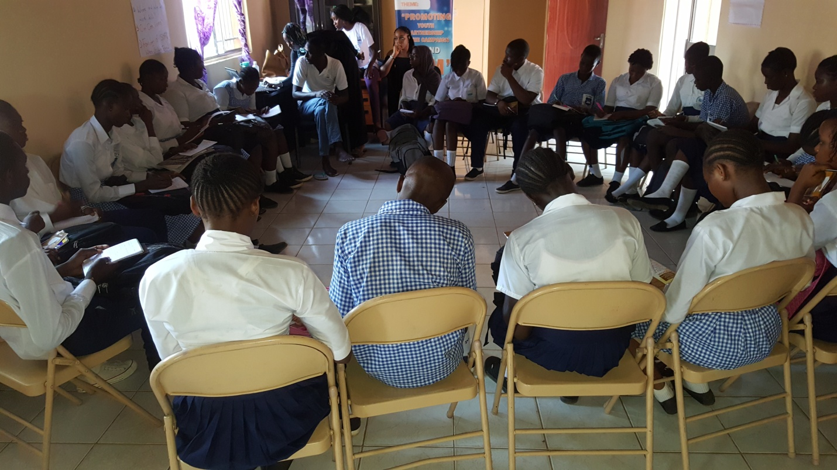

Organized & funded by:
Safe Hands for Girls

CONTENT
- Acknowledgement
- Executive Summary
- Introduction and Background
- Objectives & Expected Outcomes
- Highlights of Report
DAY 1
- Introduction to Safe Hands for Girls
- Overview of FGM
DAY 2
- Communication/ Advocacy skills
DAY 3
- Sexual and reproductive health
DAY 4
- Legal implications of FGM and Child Marriage
- Group presentations
- Drama
- Discussion on school clubs
- Photos

ACKNOWLEGDEMENT
This training is to create awareness about Female Genital Mutilation and its harmful effects.
We cannot do much without expressing our sincere gratitude to Safe Hands for Girls team and the individuals who had the courage to step up and volunteer.
Appreciation is also extended to all the schools for their participation and contribution.
Credit to Awa Gai for the compilation of this report.
EXECUTIVE SUMMARY
Safe Hands for Girls is a survivor led organization that was founded in 2013 to help end the practice of Female Genital Mutilation and other forms of Gender-Based Violence through advocacy programs, as well as to provide support to women and girls who are survivors.

INTRODUCTION
Female Genital Mutilation (FGM) is a deeply rooted tradition practiced in The Gambia by different ethnic groups throughout the country in all regions. Despite this harmful practice people believe that FGM is a religious practice and that it is obligatory. This results up to severe long-term sexual and reproductive health effects as well as social and psychological effects that can deeply affect their lives.
As a result, Safe Hands for Girls organized a Girls’ Indoor Training as part of its agenda items to end FGM. The training is for students mainly between 12- 19 years of age specifically those in the Upper Basic School and Senior Secondary Schools. This will enable them to build advocacy skills that will help contribute in the Anti-FGM Campaign.
OBJECTIVES
- Encourage the students to take part in the advocacy campaign against FGM.
- To sensitize students to have an overall understanding on the effects of FGM.
- Popularization of the Anti-FGM law.
EXPECTED OUTCOMES
- Get children to form school clubs/peer groups and join the Anti-FGM Campaign.
- That there is awareness on the legal implications against Female Genital Mutilation.

HIGHLIGHTS OF REPORT
This report highlights what was presented and recommendations made on FGM, as well as photos taken during the training. The report is divided into four days; Day 1, 2, 3 and 4.

DAY 1: 13TH OCTOBER, 2017
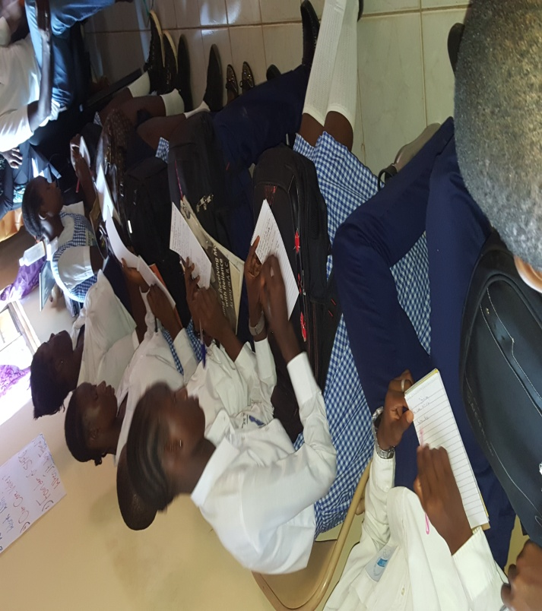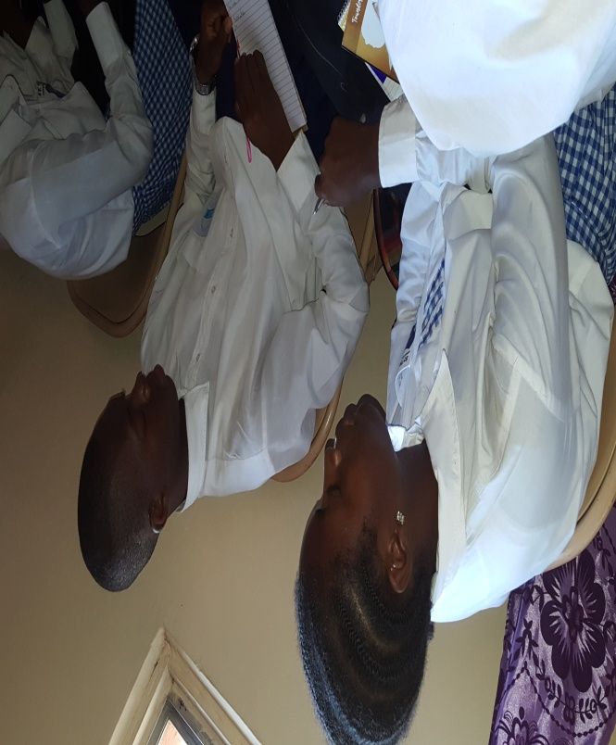
S.O.S & St. Therese’s
- Self-introduction by students
- Introduction of staff portfolio
- Tida and Marie gave a brief introduction of what SHfG is all about
- Who we are?
- What we do?
- Where and who we work with?
- Our core values?
- Founder of SHfG and when it was found?

- Overview of FGM: Mass & Newlands
- What does FGM mean to you?
- What is the history of FGM?
- WHO categories of FGM; type1, type 2, type 3
- 76% of women in the Gambia have undergone the practice of FGM
- 140 million girls are mutilated yearly
- In the 15-49 years, 75% of them has undergone the practice
- Studies has also proved that the practice is associated with associated with ethnicity
- Reasons why people still practice FGM
- What is tradition?
- Recap

DAY 2: 20TH OCTOBER, 2017
- Communication/ Advocacy Skills: Tida Njie
- Definition of public speaking
- How to be a good public speaker?
- Who is an advocate?
- Interesting answers from students on who an advocate is
- Good advocacy skills
- Q&A
- Recap
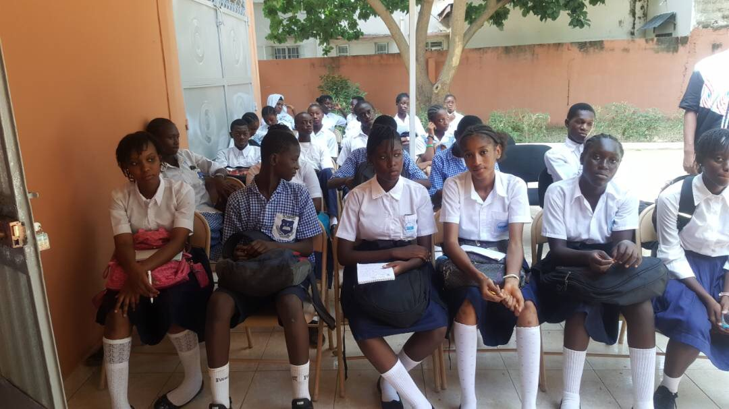
DAY 3: 3RD NOVEMBER, 2017.
- Sexual and Reproductive health: Mass Laye
- Background and description of FGM
- Types of FGM
- Visual representation on the types of FGM.
- Wound management after FGM
- Immediate and long-term physical complications of FGM
- Psychosocial and Sexual complications of FGM
- Q&A
- Recap
DAY 4: 10TH NOVEMBER, 2017.
- Legal Implications of FGM: Awa Gai
- Definition of Anti-FGM law
- Provisions that criminalizes FGM in the women’s Amendment Act 2016
- Practical demonstration of the law
- Q&A
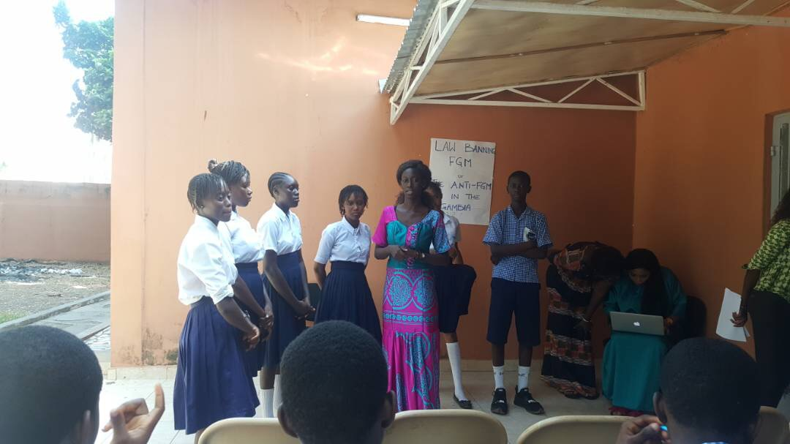
- Debate: Marie Jeng
- Debate topic: This house believes that the Anti FGM law is not sufficient
- Students divided into groups and argued substantially for and against the motion.
- Poems related to FGM were recited and everyone applauded in delight.

- Discussion on the way forward for the school clubs
- The president of the SOS school club stated that they have achieved tremendous success in enlightening students on FGM and child marriage through dramas and poems.
- They will also work on expanding the school club by involving the afternoon shift students.
- The presidents of St. Therese’s school club also mentioned that they have been sensitizing students through drama and sometime before the terms ends, they will work on recruiting grade 7 students.

