Development of Large-Scale Programs: Reaching the Poorest Adolescent Girls in the Poorest Communities of The Gambia
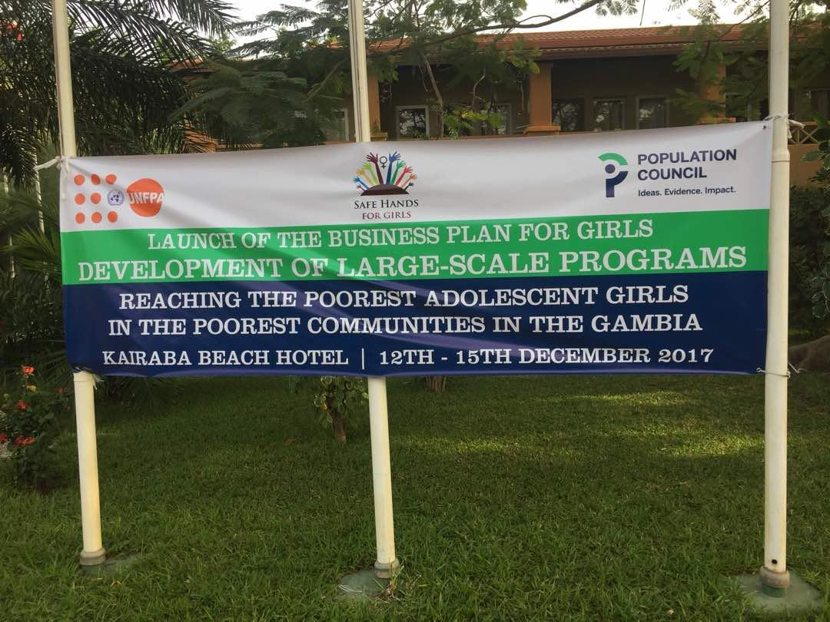

Organized by Safe Hands for Girls
Funded by Population Council and UNFPA
Venue: Kairaba Beach Hotel
Date: 12-15 December 2017

Contents
Acknowledgement
Executive Summary
Introduction and Background
Highlights of the Report

Acknowledgement
We cannot do much without expressing our sincere gratitude to the Population Council for their support of this project.
We wish to thank UNFPA for their partnership.
Special thanks to the Safe Hands for Girls team and all the individuals who participated.
Appreciation is extended to all the organizations for their contributions to the success of the workshop.

Executive Summary
The Population Council is an international, non-profit, non-governmental organization. The Council conducts research in biomedicine, social science, and public health and helps build research capacities in developing countries. Its other major program areas are in reproductive health and its relation to poverty, youth, and gender.
The United Nations Population Fund (UNFPA), formerly the United Nations Fund for Population Activities, is a UN organization. Their work involves the improvement of reproductive health; including creation of national strategies and protocols, and providing supplies and services. The organization has recently been known for its worldwide campaign against child marriage, obstetric fistula and female genital mutilation.
Safe Hands for Girls is a survivor led women’s organisation that aims to eradicate Female Genital Mutilation and all other forms of Gender Based Violence through advocacy programs, trainings, workshops and community outreach, as well as to provide support to women and girls who are survivors. Safe Hands for Girls was established in 2013 with offices in the U.S. and The Gambia.

Introduction and Background
This workshop was organized by the Population Council in partnership with Safe Hands for Girls the Gambia.
The aim was to develop a Large-Scale Program: Reaching the Poorest Adolescent Girls in the Poorest Communities in the Gambia 12TH – 15TH December 2017.
The workshop sessions were led by staffs of Safe Hands Girls and the Population Council, with commentary from on-the ground partners in the Gambia and Sierra Leone, supportive government officials, and policy makers.

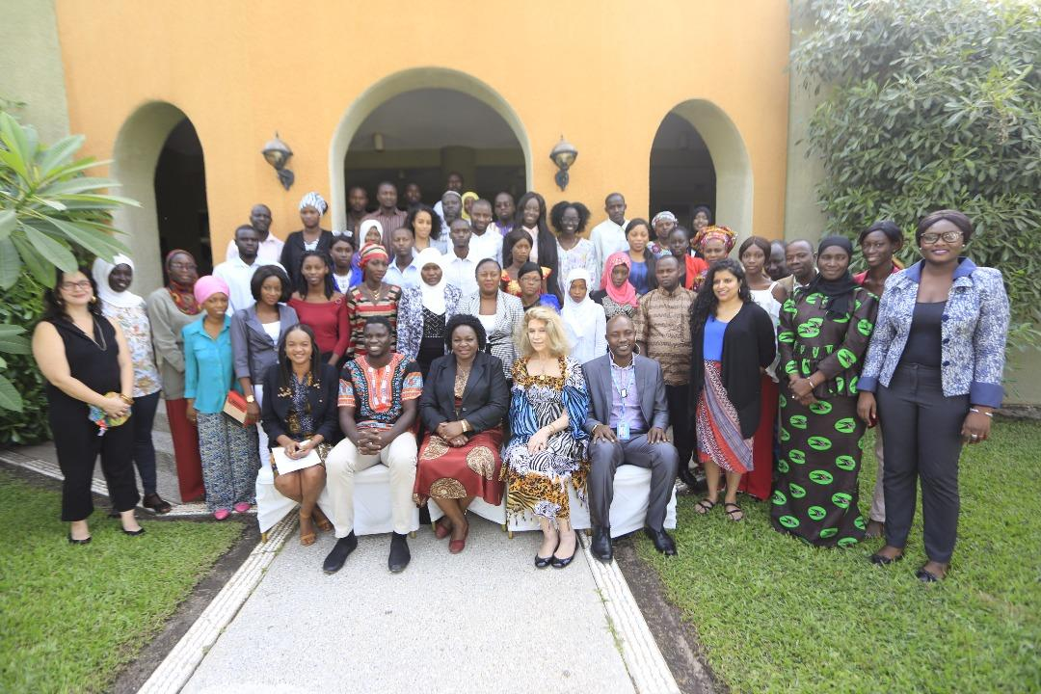
Highlights of the Report
Opening Ceremony
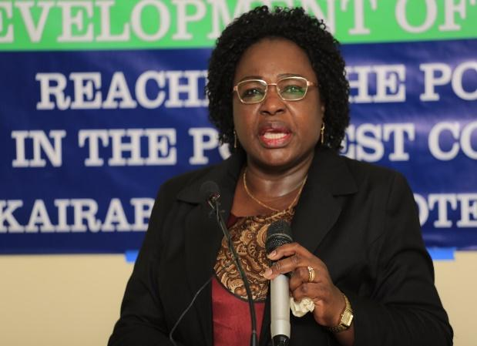
The Minister of Basic and Secondary Education, Mrs. Claudiana Cole gave the keynote address on behalf of the Vice President who was out of the country at the time. In her speech, she mentions the main objective of this work shop is to support girls who are not on track and FGM.
The program was chaired by Sait Matty Jaw, National Coordinator of Safe Hands for Girls-Gambia gave a statement on behalf of Jaha Dukureh, founder of SHFG, who was not in town by then.
MRS. CLAUDIANA COLE
Judith Bruce from the Population Council gave the welcoming remarks.
This was followed by self-introduction of participants including SHFG staffs and the team from the POP COUNCIL (US). This includes who you are, which organization you’re from, what you do as an organisation and where in the country you operate.
16 organizations in the country as well as and the media houses participated in the workshop.

The Shape of Girls’ Lives as a Foundation for Business Plan for Girls
Judith Bruce facilitated this session. During this session, we explored the experience of exclusion among the hardest to reach girls both globally and in the Gambia and the implications within the context of the SDGs. We also reviewed the business plan for girls based on the rostering done in the Gambia in two regions namely; West Coast Regions and Upper River Region respectively. The challenges making communities work for all including younger exude females. At this moment participants realized that we have been targeting young people but on the whole were the young vulnerable girls who were left behind called the off-track girls.

Reaching most excluded Population and Segments of Girls and Interrelated Dimensions of Poverty and Ill-Health
Judith’s presentation led us to a joint presentation by Eva Roca, also from the Population Council and Salma Babu, a consultant from Sierra Leone working with the Population Council, who joined the program to share her experience based on this particular area of field work including the challenges and the successes. During this session we explored the varying needs of different segments, their scenarios of risk and reviewed what we know about these segments in the Gambia. This was done in support of maps of the intensity of different conditions in order to think through on how to reach the prioritized areas and the neglected but to prioritize the segments of vulnerable girls in other words to create a safe space for girls at different levels and catch them young to make a difference.
Steps in Intentional Design
During this session, we discussed on how the Population Council approaches the girl-centred programs, this highlighted few key tools that will be used in each course, like the segmenting of the girls from age 6- 24. Here we discussed the need to involve parents when we are dealing with the younger generation especially girls.

JUDITH BRUCE
The Gambia Context - The Sub-national level
During this session, we reviewed the variation by sub-region of the Gambian girl’s experience, highlighting economic determinism and the key challenges they face. This was then followed by a segment exercise in which participants work in groups focusing on different segments of the Gambian context and think through their critical issues.

The Gambian Context - The “Universe” of Girls:
This took us to the Girls’ Rostering in the Gambia which was conducted in two regions mentioned above where the regions to see the full universe of girls and identify priority segments. Taking a real example from the Gambia’s Upper River Region and West Coast and we review what girls were found there and what this means for a program decision making.
At that moment organizations were asked to label the regions of the Gambia which areas you are operating to create a better coverage to plan in geographical location prioritizing their action plan per segment and geographical location, by using the protective asset-building approach in girls’ centred program using the building Asset toolkit. To help program staffs to identify the key knowledge, skills and other asset for girls by age, for them to be able to identify benchmarks for girls looking at the latest age of girls in the Gambian context which age required which specific tools, skills and access.

Recruitment Strategies on how to get the right girl in your program
The recruitment strategy of different segments of girls in a program activity. The appropriate venue and timing frequency, and duration of meetings must be considered to value their safety. Scanning the community resources for identification of venue for the girls’ centred platform utilizing the worksheet as a guide. Identify the potential mentors using the girl’s roster tool.
Recruitment criteria; looking at the value of the mentor’s model, their leadership quality, their job descriptions, their schedule and retainable once train and be supervising them, the girls ASERT Tools and practice using it within the context of the program, examining the threats to girl’s health, body and sexual rights.
Turning Assets into Program Contents
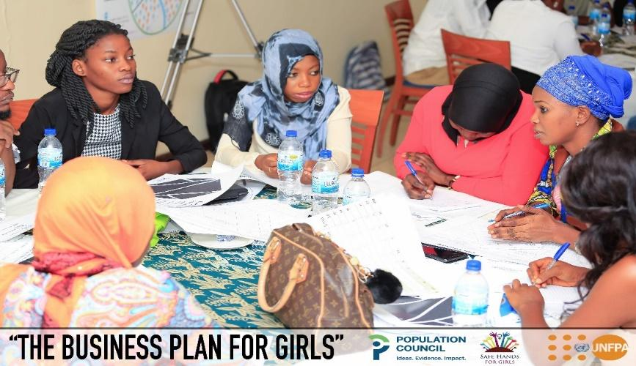
During this session, we explored how to move from identifying from learnings to useful content appropriate for low-literate populations and deliverable by mentors and appropriate for girls. A monitoring tool which will monitor and evaluate the girls and their mentors on the assets such as knowledge, life skills, and organizational strength.
The workshop was concluded with four hours of open discussion which encouraged participants to ask questions and review materials that they like. Mrs. Mam Lisa Camara, Programs Manager of SHfG advised participants that the SHFG office is open for anyone who has anything to discuss regarding the business plan for girls and support of any sort. She called on the organisations to quickly act and come up with plan of activities for work to start as soon as possible.

Conclusion
The workshop was concluded with four hours of open discussion which encouraged participants to ask questions and review materials that they like. Mrs. Mam Lisa Camara, Programs Manager of SHfG, advised participants that the SHFG office is open to anyone who has anything to discuss regarding the business plan for girls and support of any sort. She called on the organizations to quickly act and come up with the idea of activities for work to start as soon as possible.
Way Forward
- The organizations that participated in the workshop agreed to form a network in working together with this project which will be facilitated by Safe Hands for Girls.
- Programs are being developed for the communities that have already been rostered.
- Organisations/associations based in those communities are willing to work together in developing programs using the assets available in a particular city.
- A team from Safe Hands will be traveling to New York for a capacity building at the Population Council. The training will focus on understanding data, resource mobilization, and programming.

Annex 1: List of Organizations and their programming Site

ORGANIZATIONS | OPERATIONAL REGIONS IN THE GAMBIA
 | KMC/GBA | WCR | LRR | CRR | URR | NBR
EU | YES | YES | YES | YES | YES | YES
NOVA SCOTIA GAMBIA ASSOCIATION | YES | YES | YES | YES | YES | YES
FORWORD FOR YOU | YES | NO | NO | NO | NO | NO
SHFG | YES | YES | YES | YES | YES | YES
CARE FOR SEXUAL AND REPRODUCTIVE HEALTH | YES | NO | NO | NO | NO | NO
UNESCO | YES | YES | YES | YES | YES | NO
GAMBIA RED CROSS SOCIETY | YES | YES | YES | YES | YES | YES
DEMPARTMENT SOCIAL WELFARE | YES | YES | YES | YES | YES | YES
BEAKANYAN | NO | YES | NO | YES | YES | NO
ACTIVISTA | NO | YES | YES | NO | YES | YES
TAFCE | NO | NO | NO | NO | NO | YES
GAYE NJORO SKILL DEVELOPMENT CENTRE | NO | NO | NO | NO | NO | YES
GIBERE KONKO | NO | NO | YES | NO | NO | NO
JUST ACT | NO | NO | NO | YES | NO | NO
BANSANG YOUTH DEVELOPMENT ASSOCIATION | NO | NO | NO | YES | NO | NO

Annex Two: List of Participants and Contact Details.

- Isatou Bah
- Yankuba Darboe
- Binta M L Ceesay
- Fatou Sabally
- Fatou B S Badjie
- Abdoulie Taal
- Binta Njie
- Babucarr Sanneh
- Mamud Ceesay
- Buba Jadama
- Bakary Gassama
- Bubacarr Jallow
- Salla Ndimballan
- Yusupha Bojang
- Momodou M Sarr
- Hatab Sanneh
- Musa Foon
- Kaddy Sanneh
- Sariba Badjie
- Isatou Jallow
- Ebrima Saidykhan
- Maimuna Bandeh
- Mamadou A H Bah
- Mohammed Dibbasey
- Marie Jeng
- Awa Gai
- Fatoumata J. Newlands
- Mass Laye
- Mam Lisa Camara
- Sait Matty Jaw
- Isatou Suwareh
- Tida Njie

