TRAINING OF POLICE PROSECUTORS AND CHILD WELFARE OFFICERS
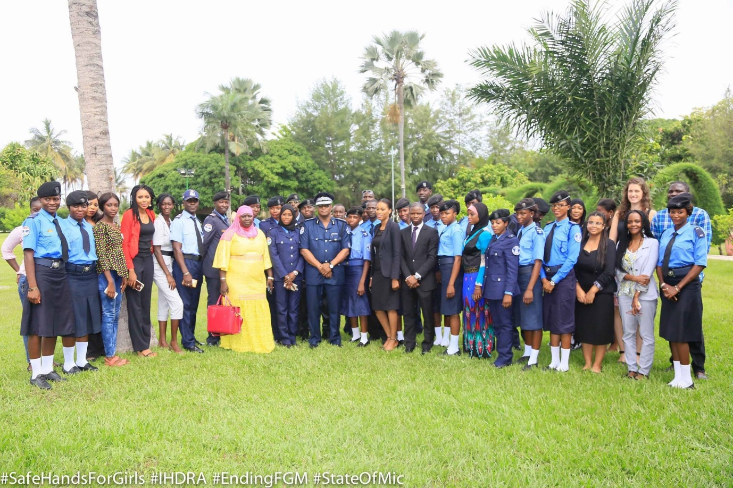
Organized by Safe Hands for Girls
In Collaboration with Institute for Human Rights and Development in Africa (IHRDA)

CONTENTS
Acknowledgements
Executive summary
Introduction and background
Highlights of report

Acknowledgements
Safe Hands for Girls would like to acknowledge the partnership, collaboration and support of the following institution:
Institute for Human Rights and Development in Africa (IHRDA)
Special thanks to the Safe Hands for Girls team and all the individuals that contributed to the success of this activity.

Executive Summary
Safe Hands for Girls is a survivor led women’s organisation that aims to eradicate Female Genital Mutilation and all other forms of Gender Based Violence through advocacy programs, trainings, workshops and community outreach, as well as to provide support to women and girls who are survivors. Safe Hands for Girls was established in 2013 with offices in the U.S. and The Gambia.
IHRDA offers pro bono legal counsel for victims of human rights abuses in Africa. They represent victims of human rights violations in cases before national courts and African regional human rights bodies, such as the African Commission on Human and Peoples’ Rights or the African Court on Human and People’s Rights.
The institute instigates cases on legal issues that they deem of particular importance, and that may not otherwise be brought to the attention of the concern courts.

INTRODUCTION AND BACKGROUND
Safe Hands for Girls (SHfG) in partnership with the Institute for Human Rights and Development in Africa (IHRDA) organised a two-day workshop on ‘’ Gambia’s Legal Provisions Concerning FGM and other Harmful Practices Against Girls’’. The workshop brought together Twenty (25) Police Prosecutors and Child Welfare Officers from various Police Stations throughout the country.
OBJECTIVES
The following objectives are underlined the purpose of the training;
- To equip the participants with knowledge of harmful practices traditional practices against girls.
- That the participants recognised the negative consequences of harmful practice against women through medical analysis
- That the participants would have a better understanding of the legal provisions concerning Female Genital Mutilation in The Gambia.
- That the participants would have an improved knowledge and skills on how to apply/use the legislations against FGM and other harmful practices against girls in the implementation of their duties as prosecutors and child welfare officers.
- That at the end of the two day training, participants would have a stronger sense of commitment and enthusiasm to make the better use of the opportunities offered by the legislations prohibiting harmful practices against women and girls in their work.
DATE & VENUE
The training-workshop took place on the 18th and 19th July 2017 at the Kairaba Beach Hotel, West Coast Region, The Gambia.
FACILITATORS
The members of the training team were:
- Mr Oludayo Fagbemi, Legal Officer at IHRDA
- Mr. Mass Laye, Medical Practitioner
- Mr Desire Bigiriman, Legal Officer at IHRDA
- Mr Momondou D Mballow, Police Superintendent from the Gambia Police Force.

AGENDA
The training agenda was as follows:
Day 1
- Opening Ceremony and Introduction
- Presentation on the Situation of FGM and harmful practices against women/girls in The Gambia: Negative consequences of harmful practices
- Presentation on Gambian Laws on FGM and other harmful practices against women and girls
Day 2
- Presentation on African and International human rights instruments that address harmful practices against women and children: Maputo Protocol, ACRCWC, CEDAW and CRC
- Presentation on Investigating and prosecuting harmful practices against girls

HIGHLIGHTS OF REPORT
DAY ONE
- OPENING CEREMONY
There was a brief opening ceremony chaired by Mr Sait Matty Jaw, from Safe Hands for Girls. The following presentations were made:
- OPENING PRAYER
Recognising the presence of members of different religious faith in the gathering, the ceremony was opened by participants praying in their own individual ways.
- WELCOME ADDRESS BY MS JAHA DUKUREH, EXECUTIVE DIRECTOR, SAFE HANDS FOR GIRLS (SHfG)
Speaking on behalf of SHfG, Ms Dukureh welcome the participants and introduced the SHfG and highlighted the role they are playing in The Gambia in advancing the advocacy on the rights of women and girls. She lamented over the under usage of the laws created for the protection of women and girls and renewed the call for the implementation of these laws. She highlighted the need for the police to strengthen the implementation of the existing laws as she reminded them that the presence of democracy does not mean the absence of laws. She further welcomed the participants and urged them to take note of the presentations and make good use of them.
- WELCOME REMARK BY MR OLUDAYO FAGBEMI, LEGAL OFFICER IHRDA
Speaking on behalf of the Executive Director of IHRDA, Mr Oludayo Fagbemi thanked the participants for answering to the call of SHfG and IHRDA and reminded them that the police have a very important role to protect and implement laws. That the training is a 2-day workshop and hopefully before the end of the training, there would be a common understanding of the laws that are in existence to provide protection for women and girls against harmful traditional practices in The Gambia. That there exists a cordial relationship between the two organisations most especially in the areas of advocacy and sensitization on women and children’s rights.
- ADDRESSS BY THE DEPUTY INSPECTOR GENERAL OF POLICE, MR MAMUD JOBE
Speaking on behalf of the Inspector General of Police, Mr Mamud Jobe addressed the participants and expressed the IGP’s delight to IHRDA and SHfG for the initiative. That the training would add to the capacity building and awareness raising of the police prosecutors and police child welfare officers undergoing the training. He urged the officers to take the training with seriousness in order to gain the best they could from the training.

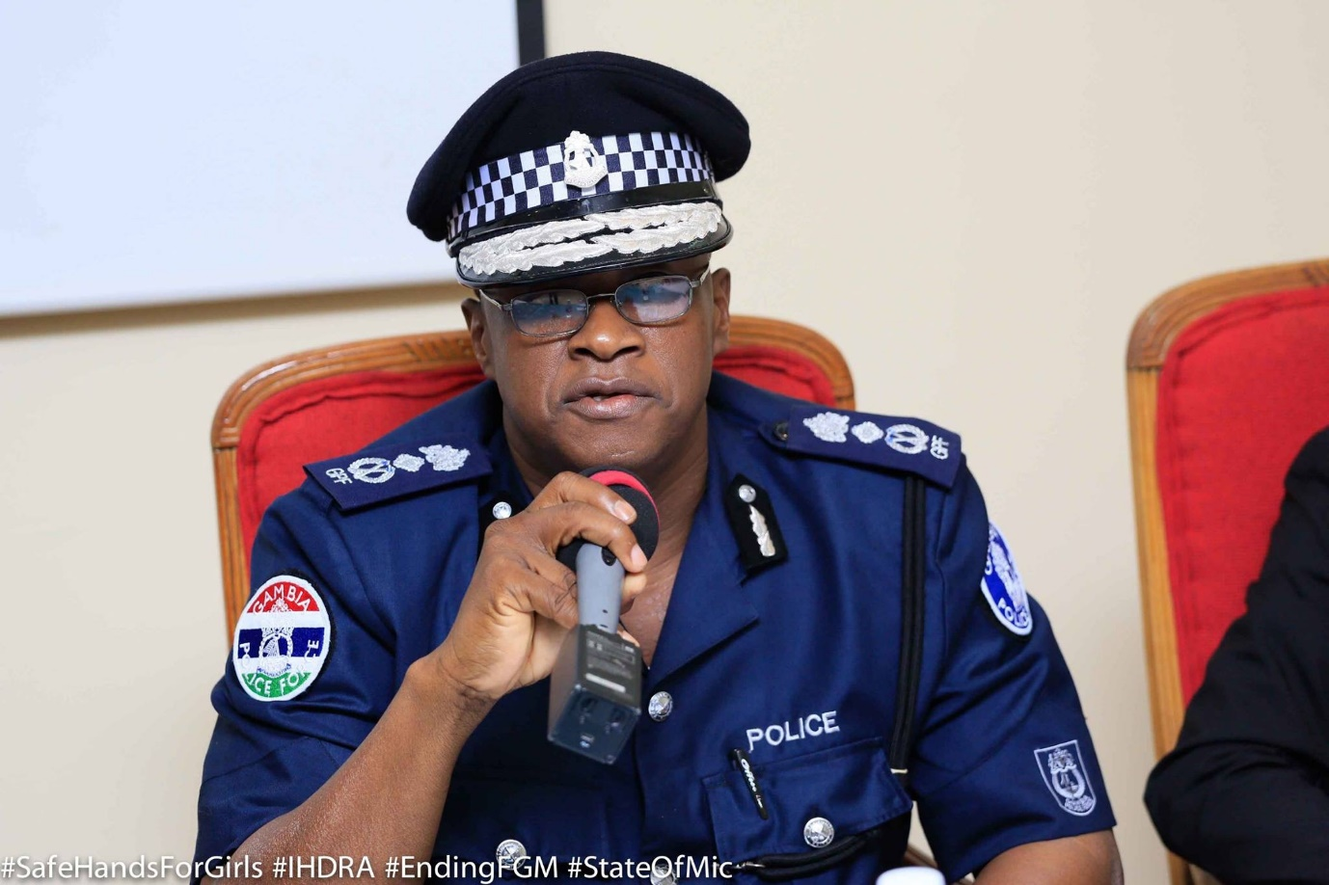
Reminding the participants that they are all experts in their respective capacities, He urged them to actively contribute and make use of the outcome of the training so as to enhance, promote and uphold the rights, welfare and well-being of women and children in The Gambia.
- KEYNOTE SPEECH BY MS MATILDA MENDY, SENIOR STATE COUNSEL, MINISTRY OF JUSTICE
In delivering the keynote speech on behalf of the Honourable Attorney General and Minister of Justice, Ms Matilda Mendy applauded the Safe Hand for Girls in partnership with IHRDA for the initiative it is very much in line with government’s ingenuity and programmes as it seeks to support and promote the implementation of the laws created by government. She reminded them of the various international human rights instruments already ratified and domesticated for the protection of women and girls as legislated in the Women’s Act 2010 and the Women Amendment Act 2015, the Children’s Act 2005 and the Children’s Amendment Act 2016, the Sexual Offences and Domestic Violence Act 2013.
She further lamented over the notable challenges especially in the area of awareness raising and the lack of disposition of the various legislations as highlighted above called for a renewed sense of support and coordination among all the relevant stakeholders.
She urged the participants to implement the laws that are in place for the promotion and protection of women and child rights without any fear or favour. She concluded by recognising that the protection of women and girls is key in the development agenda of the Ministry of Justice and of the government of The Gambia as it is known without doubt that women and youth are the cream of our society.
The opening ceremony came to an end at about 9:40 am and both participants and invited guests were invited to a group photo.

- WORKHOP MODULES

- PRESENTATION ON THE SITUATION OF FGM AND HARMFUL PRACTICES AGAINST WOMEN/GIRLS IN THE GAMBIA: NEGATIVE CONSEQUENCES OF HARMFUL PRACTICES

Presented by Mr Mass Laye
Considering the sensitivity of the topic to be discussed, Mr Mass Laye commenced his presentation by appealing to the participants not to be sentimental over the issues to analyse and he further urged them to be rational and to discard of any emotional cultural attachment.
His presentation was outlined as follows;
- To provide basic information about FGM
- The health consequences associated with FGM
- The cultural traditions that underpin the practice
- The ethical, legal and human rights implication associated with the practice.
While considering the theories behind the origin of FGM, Mr Laye gave a brief description of the three different types of FGM that are most prevalent in The Gambia. The WHO classification of the theories behind the origin of the practices, the reasons for the practice, the range of procedures carried in The Gambia and the effects of the practice on the health of girls and women. He further gave a distinction between FGM and male circumcision. That male circumcision includes the removing of the foreskin of the male genitalia while FGM included the removal of an organ from the female genitalia which has more health consequences than male circumcision and thus the mutilation.
In explaining the traditional concept for the practice, he provided that it is mostly practice based on customs, beliefs and values of a community which is govern and influence by people’s behaviour and that this often constitute learned habits which are passed on from generation to generation.

He maintained that the various reasons for the practice can be narrowed to the following; Socio-cultural, Hygienic and aesthetic, Spiritual /religious and Psycho-sexual tendencies.

He backup his analysis with the statistics of the prevalence of the practice both globally and nationally. That about One Hundred Million to One Hundred and Forty Million (100-140,000,000) girls are at mutilated yearly and that at least Two Million girls are at risk of mutilation. That in The Gambia, women aged between15-49 is 75% and that the prevalence rate is Higher in rural areas at 79% than in urban areas at 72%. That Communities with the highest rate are Basse and Mansakonko 97% and 94% respectively while Banjul records the lowest at 47%.

Mr Laye further outlined the immediate and long-term physical complications as well as the psycho social and sexual complications of the practice. That the act does not only entail severe pain due to the operation being performed with crude instruments and without anaesthetic or the Injury it can caused to the adjacent tissue of urethra, vagina Perineum and rectum, struggling of the victim or the use of crude instruments or the lack of sufficient knowledge of the anatomy and physiology of the external genitalia, the poor eyesight or a careless technique of the cutter, etc. That there is also the causation of haemorrhage, pelvic infection, keloid scar, Abscess, Menstrual difficulties, obstructed labour. There are also the psychosocial complications which include fear of sexual intercourse, loss of self-esteem and sexual dysfunction, damage to marital relationship etc.
Mr Laye used evidence-based presentation with vivid pictures showing how the cutting is actually done in practice.
At the end of the presentation, participants acknowledged their appreciation of the presentation. Thereafter, questions were raised by the participants with respect to the effectiveness of the Health Sector in sensitising people about the health implications, the religious impression underlying the practice, how to detect infection and whether infertility can be treated. In responding to the questions raised, Mr Laye made it clear that Stakeholders have been meeting yearly since 2012 to find conventional means and ways to discourage practicing communities but due to the deeply rooted culture of the practice in the society, there is no positive breakthrough but that there is more room for improvement. Responding to the religious aspect, he dispelled the notion that FGM is an Islamic religious obligation as studies have shown that non -Muslims also do the act as well non- believers. With regards the question on infection, Mr Laye stated advise for regular medical check -up and with regards the question on infertility, Mr Laye stated that infertility has to do with the tubes and where the tubes are blocked, it can be flush but where the tubes are infected, most of the time can determine and

- INTRODUCTION TO HUMAN RIGHTS- WOMEN’S RIGHTS ARE HUMAN RIGHTS
Presented by Mr Desire Bigirimana
Mr Bigirimana described human rights as the basic standards or requirements without which people cannot live in dignity as human beings. He gave the following characteristics as being the tenets of human rights; their inherent nature, universality, inalienability and indivisibility and that it can be further categorise into; civil and political rights, socio economic rights, Environmental, Cultural and developmental rights.
The participants were also taken through the sources of international law and the nomenclatures/terminologies always used in describing international agreement/treaties and its characteristics. He further discussed the correlation between the rights and duties and whether having rights automatically involves duties and to regards, he brought out the rights for women and children and highlighted the duty bearers responsible for upholding such rights. Furthermore, he discussed the restrictions attached to some of these rights and mentioned ways in which some of these rights could be restricted and the need for such restriction. He brought out the arguments surrounding the fact that some rights need to be restricted for the protection of society at large and also for the perseverance of orderliness. That understanding human rights includes knowing what rights we should have as human beings and deciding if these rights should or should not be restricted. Many human rights treaties allow the limitation of some human rights in times of “public emergency.”
On the issue of what would constitute a human rights violation or abuse, the presenter stressed the need for one to understand the basic tenets of how international law works vis-s-vis our national laws and that what we call a human rights violation is always a breach of international human rights law but can also be a breach of national law. However, an infraction of national law is usually not referred to as a human rights violation if it is not also a breach of international human rights law. In addition, he pointed those to be held responsible for violations of human rights and they could be the State actors, Non- State actors, Multinational and International Companies and or Common Criminals.

Mr Bigirimana further outlined that a human rights violation could be committed either by way of an act or omission.
In bringing out the nexus between human rights and women’s rights, Mr Bigirimana reiterated the fact that human rights provisions apply to women in the same way as they apply to men. However, taking note of the fact women still face all sorts of discrimination, they are therefore at an increased risk of poverty, violence, ill health and poor education, hence the need for more awareness raising and sensitization on these issues. That it was important to note that the provision of women’s rights is not an addition but the realisation of their vulnerability.
During the presentation, the vulnerability of women and children especially the girl child dominated the discussion.
- PRESENTATION ON GAMBIAN LAWS ON FGM AND OTHER HARMFUL PRACTICES AGAINST WOMEN
Presented by Mr Oludayo Fagbemi
Mr Fagbemi’s presentation on this topic gave an overview of the various legislations complementing the 1997 Constitution of the Republic of The Gambia. He highlights the following local laws protecting women with particular reference on the Women’s Act 2010, the Sexual Offences Act 2013, Tourism Offences Act 2003, Children’s Act 2005.
Mr Fagbemi provided the fundamental rights enumerated in the Constitution (Protection from Inhumane Treatment, Right to Marry , Rights of Women, Rights of Children, Cultural Rights )and stated the need for them to be respected and upheld by all government bodies and persons in the Gambia as provided by law, and that these rights shall be “enforceable by the Courts in accordance with this constitution.” That ‘’every person in the Gambia is entitled to the protections provided for in Chapter Four, “but subject to the respect for the rights and freedoms of others and for the public interest’’ as provided by the Constitution.

Mr Fabemi further engaged the participants through the provisions of the Sexual Offences Act 2013 as it relates to defilement and rape, the Women’s Act 2010 on the rights of women and girls, the Women Amendment Act 2015 which seeks to prohibit and provide punitive measures for the act of FGM and the categories of persons that can be held liable for the act, the Children’s ACT 2005 and the Children Amendment Act 2016 on the prohibition punitive measures of Child Marriage and Child Betrothal.
The interactive nature of the presentation brought out the issues of concern over the prevalent nature of child marriage and child rights in general.

DAY 2;

- PRESENTATION ON AFRICAN AND INTERNATIONAL HUMAN RIGHTS INSTRUMENTS THAT ADDRESS HARMFUL PRACTICES AGAINST WOMEN AND CHILDREN

Presented by Mr Oludayo Fagbemi
Day two began with a presentation from Mr Fagbemi of the IHRDA who briefly gave an insight into the Convention of the Rights of the Child (CRC) and the African Charter on the Rights and Welfare of the Child ( ACRWC) being the two legal frameworks from which the Children’s Act of 2005 was derived from and the Convention on the Elimination of All forms of Discrimination Against Women (CEDAW) from which the Women’s Act 2010 was derived from.. Mr Fagbemi divided his presentation into the substantive rights guaranteed under the laws and the application of these rights where required. He highlighted the CRC as being an international instrument and the ACRWC as being a regional instrument and further stated that both instruments are rarely used by the Gambia at the regional or international level and the African Charter on Human and People’s Rights (ACRPR).
He gave the definition of harmful practices as defined in the Maputo Protocol and CEDAW as:
All behaviors, attitudes and/or practices which negatively affect the fundamental rights of women and girls, such as their right to life, health, dignity, education and physical integrity.” (article 1.g)
CEDAW defined it as:
Persistent practices and behaviors that are grounded in discrimination on the basis of, among other things, sex, gender, age, in addition to multiple and/or intersecting forms of discrimination that often involve violence and cause physical and/or psychological harm or suffering. (see Joint General Recommendation 31, CEDAW

Furthermore, he briefly described the various harmful traditional practice as highlighted in these instruments to include and not limited to slaver, female genital mutilation and child marriage.
Considering the prevalent practice of child marriage, Mr Fagbemi took his time to discuss amongst others the Addis Ababa Declaration on Ending Child Marriage in Africa in April 2014 by The African Committee of Experts on the Rights and Welfare of the Child, which calls upon the African Commission, the ACERWC, the AU, CSOs, UN agencies, and other international partners including the private sector, to provide technical support to efforts aimed at eliminating child marriage, take child marriage as a policy priority, and facilitate awareness, while emphasizing the primary responsibility of the state.
In the implementation of these provisions, he gave an analysis of the Ecowas Court’s position in the cases of child marriage in Maimuna Abdulmunini (represented by Avocats Sans Frontieres) v. Nigeria and in Hadijatou Mani Koraou v. Niger. a consideration was also made on the Female Genital Mutilation case involving Zimbabwe Human Rights NGO Forum v Zimbabwe.
The positive attitude of the Ecowas Court in these instances upheld the ground the ‘’ Human rights standards do not contain merely limitations on State's authority or organs of State. They also impose positive obligations on States to prevent and sanction private violations of human rights. Indeed, human rights law imposes obligations on States to protect citizens or individuals under their jurisdiction from the harmful acts of others. Thus, an act by a private individual and therefore not directly imputable to a State can generate responsibility of the State, not because of the act itself, but because of the lack of due diligence to prevent the violation or for not taking the necessary steps to provide the victims with reparation” (Zimbabwe Human Rights NGO Forum vs Zimbabwe).

During the course of the interactive presentation, issues challenging the successful litigation of cases in court were raised and some of the following were highlighted;
- The withdrawal of cases at the Police level either by the victim or family members of the victim
- The need for specialised Women’s Courts as well
- A revision of the Women Amendment Act 2015 to address the issue of child victims of FGM who are being smuggled to other countries for the cutting.

- PRESENTATION ON INVESTIGATING AND PROSECUTING HARMFUL PRACTICES AGAINST GIRLS

Presented by Mr Momodou D. Mballow
Mr Mballow commenced his presentation by stating that the aim is for the participants to understand the laws that empower Police Officers to investigate and prosecute cases of Traditional Harmful Practices especially cases of FGM, to be able to assess safety threats and risk factors in traditional harmful practices and FGM investigations. He further provided for the objectives to be as follows;
- Know how to plan the logistics of an investigation, including issues of timing, location, sequencing, and teaming with other professionals in the form of multi-disciplinary teams
- Know the stages of the interview and the methods to be used in interviewing alleged victims, non-offending parents, alleged perpetrators, and collateral contact
- Understand the dynamics involved in Traditional Harmful Practices FGM
Mr Mballow further took the participants through the meaning of crime and how crimes are to investigated and prosecuted, the expressed and implied powers of the police to conduct searches, compile information and establish facts within the law as provided by the following laws. He took his time to explain the laws to be considered in dealing with a case of FGM and the following laws were considered in detail:

- Constitution of the Gambia 1997
- Children's Act 2005
- Women Act 2010 and (Amendment Act 2015)
- Criminal Procedure Code
- Police Act
- Criminal Code
- Finger Prints Act
- Case law (persuasive authority)

As the offence of FGM is aptly describe in the Women’s Amendment Act 2015, Mr Mballow brought out the elements to look for based on the description during investigation and prosecution of such cases and the parties that could be involve in commission of the crime. He however, reminded them of the need to always consult and liaise with the Medical practitioners during the investigation and prosecution of such cases as they are experts to establish the act of FGM has been conducted on a woman or girl.

Despite the giant strides of the Government of The Gambia in creating the legislations, there are still gaps within the Act which provides lacunas especially with respect to instances whereby a parent or guardian may take a woman or girl outside the jurisdiction of The Gambia to another Jurisdiction for the commission of the act of FGM. That the law fails to provide for remedies to be instigated when such happen. Furthermore, he noted the fact that the Act failed to provided compensation to be awarded to victims of FGM. He called on the government of The Gambia to revisit the law and provide the necessary adjustments to enable it cover the prevailing circumstances as highlighted above.

Mr Mballow recognised the shortcomings of investigating officers and prosecution officers and urged them to take particular cognizance of the sensitivity of investigating cases of FGM and the need to be mindful of the following;
- Accurate recording and keeping of information from victims and witnesses
- Proper investigation and collection of evidence
- Choosing the appropriate location for interviewing victims and witnesses
- Maintaining privacy and confidentiality of victims and witnesses
- Proper management of exhibits for prosecution

He further encourages the participants of the need for referrals where the instance arises specially for medical, psychological and psychosocial care support to Department of Social Welfare, Female Lawyers Association of Gambia etc.

Before the end of the presentation, participants were able to recognise and appreciate the rudiments involved in the investigation and prosecution of cases of FGM and with a strong sense of commitment pledged to uphold the law in protecting women and girls against harmful traditional practices.

CONCLUSION
The training was successfully concluded at about 14:15hrs and in delivering the final remarks, Mr Fagbemi of IHRDA thanked the participants for being part of the program and assured them of IHRDA’s commitment for continued collaboration and support in the fight against harmful traditional practices against women and children. On behalf of Executive Director of SGH, Ms Lisa Camara thanked the participants for their participation and urged them to make use of the presentations and discussions as underwent during the two-day sessions for better practice in their daily activities. The vote of thanks was delivered by Ms Amie Secka (Police Prosecutor) who thanked the organisers and assured them of their readiness to make use of what was learnt during the sessions in their daily activities.

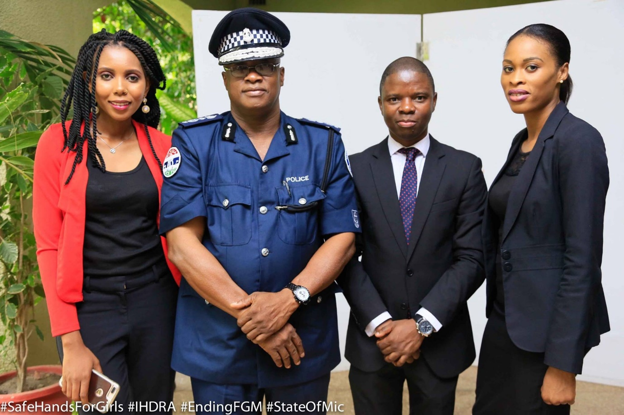

Report Prepared by
Ms Bafou Jeng
Tel: +220 2223616/ 3634472

